ORGANIC CHEMISTRY NOTES
2017
sssaul200@gmail.com
0782683951/0756439331

CHAPTER 1
INTRODUCTION
What is Organic chemistry?
Is the branch of chemistry that deals with the study of compounds of carbon
All organic compounds contain carbon together with one or more other elements such as hydrogen, oxygen, chlorine, Nitrogen and sulphur
These organic compounds range from simple molecules such as methane, ethene, ethyne, giant molecules such as Deoxyribonucleic acid (DNA),rubber, cotton, drugs, insecticides, explosives and photographic films- of which all these compounds are of great importance in everyday life
Organic chemistry is also the foundation for basic studies in Botany, nutrition, agriculture, pharmacy, technology, forestry, zoology, e.t.c
UNIQUENESS OF CARBON IN ORGANIC COMPOUNDS
Carbon behaves differently from the rest of the group members due:
- Small Atomic radius
- High electronegativity
- Lack of vacant orbital
Some of the properties in which Carbon differs from the rest of the members include:
- It forms a stable multiple bonds with itself and with other non-metals.
- Carbon can form a number of hydrocarbons because it can catenate. Catenation is the ability of the element to form bonds between atoms of the same element.
- It forms gaseous oxides unlike other members
- The halides are stable to hydrolysis.

CHARACTERISTIC PROPERTIES OF ORGANIC COMPOUNDS
Most organic compounds are:
- Covalently bonded and generally gases, volatile liquids and low melting point solids with few elements such as carbon, hydrogen, sulphur, nitrogen and halogens
- Low melting and boiling point compounds
- Generally insoluble in water except those with polar functional groups such as
- The reactions are generally slow although some are explosive and most reactions require catalysts
REACTANTS AND REACTIONS
In chemical reactions, the reactants molecules are that are attacked are called SUBSTRATE but the general term given to the attacking substrate is called a REAGENT.
Substrates and Reagents usually interact to yield the products involve redistribution of electrons.
Generally there are two ways in which a covalent bond can be broken include:
(a) Homolytic cleavage
In this type, the bond is broken symmetrically and each atom remains with one electron to form a radical. Example include
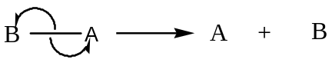
These types of reactions are usually catalysed by:
- Ultraviolet light or short wavelength light or sunlight
- High temperatures
- Peroxide
(b) Heterolytic cleavage
In this of the reactions, the bonds are broken unsymmetrically generating cation and anion
If the molecule contains different atoms with different electronegativity, the tendency of ions formation differs.
These breakages usually take place in solvents of high ionizing power which is catalyzed by ionic polar catalysts
Example include: If A is more electronegative than B, then
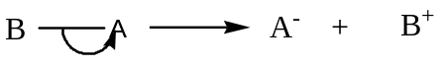
CARBOCATION OR CARBONIUM IONS
These are formed when fragments of a molecule in which a group and the bonding electrons are removed from the carbon chain
Carbocations are divided into 1⁰, 2⁰ and 3⁰
The stability of the Carbocations depend on the number of the electron releasing group e.g. CH₃ and is expressed as 3⁰> 2⁰> 1⁰
ELECTROPHILES AND NUCLEOPHILES
Electrophiles are species which are electron loving since they are electron deficient while Nucleophiles are species which are electron rich
Examples of Electrophiles and Nucleophiles include:
Electrophiles: 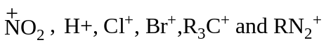
Nucleophiles:
HYDROCARBONS
These compounds that contain carbon and hydrogen as the only elements present.
They are classified as:
(a) Saturated hydrocarbons
These are hydrocarbons that contain a carbon- carbon single bond e.g. in Alkanes
(b) Unsaturated hydrocarbons
These are hydrocarbons that contain multiple bonds between the carbon atoms e.g Alkenes
Further classification includes:
(a) Aliphatic Hydrocarbons
These are hydrocarbons that contain low carbon-hydrogen ratio. Usually on burning, they burn with a non-sooty flame.
(b) Aromatic hydrocarbons
These are hydrocarbons that contain a high carbon- hydrogen ratio. Usually on burning, they burn with a sooty flame. These compounds are usually considered as derivatives of benzene.
N.B Also Alicyclic hydrocarbons which are hydrocarbons in which carbon atoms are arranged in the ring other than benzene ring e.g
FUNCTIONAL GROUPS AND HOMOLOGOUS SERIES
Homologous series is a series in which organic compounds can be placed. The characteristics of homologous series include;
- Member of a homologous series can be represented by a general formula e.g. C_{n}H_{2n+2} for Alkanes, C_{n}H_{2n} for Alkenes
- Each member of a series has a similar method of preparation
- Members in a given series has a similar chemical properties to each other
- As a series is ascended down, a methylene group is added to each successive member therefore physical properties such as boiling and melting points change slightly.
- Several homologous series are regarded as alkane derivatives since the hydrogen atom in the alkane is replaced by a functional group
Functional group is atom or group of atoms which impart specific chemical properties to the chemical compounds containing then regardless of the nature of the hydrocarbon part of the molecule.
Generally Organic compounds are classified based upon the functional group because compounds having the same functional groups have the similar chemical properties.
The table below shows some of the examples of functional groups:
Name | Structural formula | Examples
Alkane | RH or C_{n}H_{2n+2} | CH₃CH₂CH₃
Alkenes | RCH=CH₂ or C_{n}H_{2n} | CH₃CH=CH₂
Alkynes | or C_{n} H_{2n-2}
Halogen compounds | RCH₂X (x=Cl, Br and I) | CH₃CH₂Cl
Alcohols | RCH₂OH or C_{n}H_{2n+1}OH | CH₃CH₂OH
Carbonyl compounds | Aldehydes: RCHO or C_{n}H_{2n+1}CHO  Ketones: RCOR or C_{n}H_{2n+2}CO | CH₃CH₂CHO  CH₃COCH₃
Carboxylic acids | RCH₂COOH or C_{n}H_{2n+1}COOH | CH₃COOH
Amines | RCH₂NH₂or C_{n}H_{2n+1}COOH | CH₃CH₂NH₂,CH₃NHCH₃
Ethers | ROR or C_{n}H_{2n+1}O | CH₃CH₂OCH₃

TYPES OF ORGANIC REACTIONS
Organic reactions are usually initiated by Electrophiles or Nucleophiles or free radical attack upon the substrate. These reactions include:
(a) Substitution or Displacement reactions
These reactions involve the direct displacement of an atom or group by another atom or group.
The number of atoms displaced depends on the nature of the reactants and conditions under which the reaction is carried out.
Generally they are represented as;
e.g.
Substitution reactions are divided into two classes:
(i) Nucleophilic substitution reaction (S_{N}).
These are reactions whereby electron rich species simply displaces an atom or group. These reactions are undergone by Alkyl halides.
(ii) Electrophilic substitution reaction (S_{E})
These are reactions where by electron deficient group displaces an atom. These reactions are undergone by Benzene where hydrogen atom is replaced by an electron deficient group
According to the number of species involved in the formation of the activated complex in the rate determining step, Nucleophilic substitution reaction is divided into two:
(i) Nucleophilic substitution unimolecular (S_{N}1) where a single species is involved.
(ii) Nucleophilic substitution Bimolecular (S_{N}2) where two species are involved.
(b) Elimination reactions
These are reactions involve the removal of atoms or groups of atoms from two adjacent atoms to form a multiple bond or unsaturated compound.
These reactions are usually encountered to yield alkenes and alkynes
Generally they are represented as;

e.g.
Elimination reaction is also divided into two types based upon the number of species involved in the formation of activated complex in the rate determining step.
(i) Elimination Unimolecular (E₁) e.g dehydrohalogenation and dehydration of 3⁰ Alkyl halides and Alcohols respectively
(ii) Elimination Bimolecular (E₂) e.g dehydrohalogenation and dehydration of 2⁰ Alkyl halides and Alcohols.
(c) Addition reactions
These are reactions wherebythe attacking reagent simply adds across the unsaturated bond of the reactant to saturated product.
These reactions are usually the reverse of the elimination reactions and the unsaturated reactants act as Nucleophiles and consequently more vulnerable to attack by Electrophiles.
These are reactions are generally represented as:
Example include
Addition reactions are divided into classes:
(i) Electrophilic addition reactions (A_{E})
These are reactions where the electron loving species simply adds itself to unsaturated compound e.g. addition reactions of alkenes and alkynes.
(ii) Nucleophilic addition reactions (A_{N})
These are reactions where the electron rich species simply adds itself to the unsaturated bond of the bond e.g. addition reactions of carbonyl compounds
(d) Rearrangement reactions
These are reactions which involve the migration of an atom or group from one site to another within the same molecule. It involve the migration of a functional group from one position to another within the same molecule
Example include
R
C
H
C
H
C
H
2
B
r
R
C
H
C
H
C
H
2
B
r
MECHANISM OF ORGANIC REACTIONS
Mechanisms of reaction are sequence steps by which the reactions take place from start to the end. The mechanism is worked out from a study of the kinetics of the reactions. Other method include spectroscopy and use of radioactive isotopes
ISOMERISM
This is the existence of different compounds with the same molecular formulae but different structural formulae.
Compounds with same molecular formulae but different structural formulae are known as Isomers. Isomerism is divided into two classes:
(a) Structural Isomerism
This is the type of isomerism which shows the sequence in which the atoms in a molecule are bonded or linked.
It is divided into three classes:
(i) Chain Isomerism. This is the type of structural isomerism where by the isomers differ in the carbon chain. The isomers usually have the same functional group and belong to the same homologous series.
It can be divided into classes’ i.e. Straight chain and branch chain
Example included: Q has molecular formula C₄H₁₀, write down possible chain structural formula of Q. Since the M.F. is C₄H₁₀ isomers are:
(ii) Positional Isomerism. This is the isomerism where the substituent groups are in different positions in the same carbon skeleton. The isomers are chemically similar because they possess the same functional groups
(iii) Functional Isomerism. This is the isomerism where by the isomers in different homologous series have different functional groups.
Examples include:
(a) A compound Q has Molecular formula C₂H₆O
The isomers are CH₃CH₂OH (from Alcohol) and CH₃OCH₃ (from ether)
(b) A compound W has molecular formulaC₃H₆O
The isomers are CH₃COCH₃ (from Ketones) and CH₃CH₂CHO (from Aldehydes)
(c) A compound Z has molecular formula C₄H₈O₂
The isomers are CH₃CH₂CH₂COOH (from Carboxylic acid) and
CH₃COOCH₂CH₃ (from Esthers)

(b) Stereoisomerism
This is the type of isomerism where by the compounds have the same molecular formula and same structural formula but differ in the spatial arrangement of the bonds.
Stereoisomerism is divided into two classes:
(i) Cis-trans Isomerism (Geometrical Isomerism)
This occurs in compounds in which free rotation is prevented by the presence of multiple bonds, a ring or steric factors.
Geometrical Isomers differ in spatial arrangement giving rise to Cis isomers which has identical atoms or groups on the same side of the multiple bond and a Trans isomers which has the atoms or groups in opposite side.
Examples include:
(ii) Optical Isomerism
This occurs in compounds with four atoms or groups attached to the same carbon such that the isomers obtained are not super imposable on the mirror images.
These isomers which are not super imposable are referred as to as Enantiomers and the structures are said to be chiral.
Example includes:
Enantiomers have same physical properties but may be distinguished from each other by the ability they rotate polarized light due to optical activity.
If the rotation of the plane is in clockwise direction (to the right), the substance is dextrorotatory (with + sign) while if the rotation is in the anticlockwise (to the left), the substance is laevorotatory (with – sign)
The degree of rotation is determined by use of a polarimeter.
METHODS OF RELATIVE MOLECULAR MASS DETERMINATION OF ORGANIC COMPOUNDS
The four commonly used methods for determining the relative molar mass of organic compounds include:
(a) Vapour density measurements using gas syringe or Victor Meyer’s method
Example
A hydrocarbon Q contains 91.3% carbon and the rest hydrogen.
(a) Determine the empirical formula of Q (C=12, H=1)
(b) The vapour density of Q is 39 at a constant temperature and pressure.
Determine the:
(i) Molecular mass of Q
(ii) Molecular formula of Q
(c) Q burns with a sooty flame, write down the possible isomer(s) of Q

Soln:
(a) Elements: C H
Masses (%): 91.3 8.7
Moles: 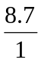
= 7.6083 8.7
Mole ratio: :
= 1 : 1
E.F. of Q is CH
(b) (i) From 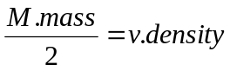 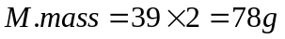
(ii) From M.F= (E.F) _{n} = M .mass
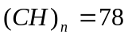 Or n (12+1) = 78
Of Q is C₆H₆
(c) The molecular structure of Q is
Example
When 0.29g of substance Q was burnt in oxygen, 0.66g of carbondioxide and 0.27g of water were formed.
(a) Calculate the empirical formula of Q
(b) Q forms a yellow solid with 2, 4-dintrophenylhydrazine. The vapour density of Q is 29.
(i) Write the structural formulae of the isomers and names of Q
(ii) What type of structural isomerism is exhibited by Q.?
(iii) How can the structural isomers be differentiated
Soln:
(a) RFM of CO₂ = 1(12) + 2(16) = 44 Elements: C H O
RFM of H₂O = 2(1) + 1 (16) = 18 Masses (g): 0.18 0.03 0.08
Mass of Carbon in Q = moles: = 0.015 0.03 0.005
Mass of Hydrogen in Q = 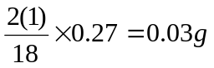 Ratio: 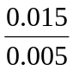
Mass of Oxygen in Q = 0.29- (0.18+ 0.03) 3: 6 : 1
= 0.08g E.F. of Q is C₃ H₆ O

(b) (i) M. mass of Q = 29×2 = 58g (C₃H₆O)_{n} = 58
n(3(12) +6(1) + 1 (16)) = 58 or 58n = 58 or n= 1
M.F of Q is C₃H₆O with S.F CH₃COCH₃ –Propanone and CH₃CH₂CHO- Propanal
(ii) Functional Isomerism
(iii) By using Ammoniacal Silver nitrate solution
Example
(a) Define the hydrocarbon
(b) A compound X, on combustion gave 0.629g of carbondioxide and 0.257g of water. Determine the empirical formula of X
(c) When 0.10g of X was vapourised, it occupied a volume of 40cm3 at s.t.p
(i) Calculate the molecular mass of X
(ii) Determine the molecular mass of X hence write the structural formulae of the possible isomers
Soln:
(a) A compound that contains carbon and hydrogen as the only elements present
(b) Mass of Carbon =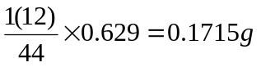 (ii) (CH₂) _{n} = 56
Mass of Hydrogen = n (12+2) = 56
Elements: C H M.F of X is C₄H₈
Moles: 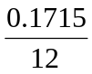 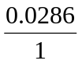
= 0.0143 0.0286 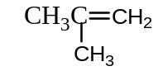
Hence mole ratio = 1:2 E.F of X is CH₂ 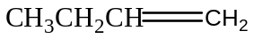
(c) (i) From PV = nRT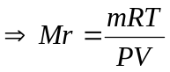 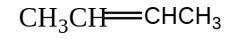
=
(b) Colligative Properties of dilute solutions containing non-volatile solutes
These include lowering of vapour pressure, cryoscopy, ebullioscopy and osmotic pressure
Cryoscopic method has an advantage over Ebullioscopic method that it is not affected very much by pressure changes of which boiling points depend on the atmospheric pressure
Molecular mass of polymers is determined using Osmotic pressure because they are easily denatured by heat and a amount of polymer changes the osmotic pressure of the solvent significantly.
Example
A compound W contains Carbon, Hydrogen and oxygen. When 1.5g of W was burnt in excess oxygen, 1.467g of carbon dioxide and 0.297g of water were formed.
(a) Determine the empirical formula of W
(b) 7.5g of W was dissolved in 204.4g of water to a solution .The prepared boiled at 100.212ºC.
The boiling point constant of water is 0.52ºC per mole per kg.
Determine the:
(i) Molecular mass of W
(ii) Molecular formula
(iii) Structural formula of w
(c) State the condition(s) employed in order for W to react with following compounds.
In each case write the equation of reaction
(i) Sulphuric acid
(ii) Potassium manganate (VII) solution
(d) Name the reagent that can be used to distinguish between W and Methanoic acid.
Soln:
(a) Mass of hydrogen = = 0.033g, Mass of Carbon =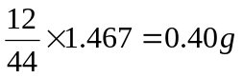
Mass of oxygen = 1.5- (0.033+0.40) = 1.067g

Elements: C H O 0.033 0.033 0.067
Moles: 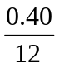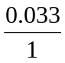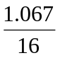 Mole ratio: 1: 1: 2
E.F of W is CHO₂
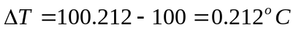
(b) (i) 204.4g of water contains 7.5g of W
1000g of water contains 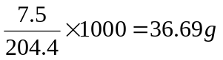of W.
0.212ºC is the elevation in b.p.t caused by 36.69g of W
0.52 ºC is the elevation in b.p.t caused by 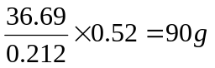of W
(ii) (CHO₂)_{n}= 90 n = 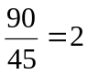M.F of W is C₂H₂O₄
(iii) 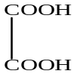
(c) (i) Concentrated acid and heat
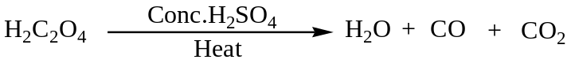
(ii) Acidified Potassium permanganate solution and warm the solution to about 70ºC
(d) Ammoniacal Silver nitrate solution
Example
(a) Differentiate between Diffusion and Osmosis
(b) The osmotic pressure of a solution containing 4.00gdm⁻³ of polyvinylchloride,
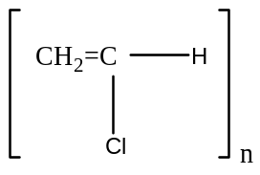
In dioxin is 65Pa at 20ºC. Determine the number of monomers, n, in the polymer.
(c) State two conditions under which the Osmotic laws cannot be obeyed
Soln
(a) Diffusion is the movement of molecules from high concentrated area to a low concentrated area while Osmosis is the movement of solvent molecules from a dilute solution to concentrated solution across a semi-permeable membrane
(b) From 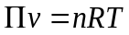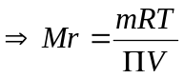 =
n (24+3 + 35.5)=149.91X10³
(c) When the solution is concentrated
When the solute associate or dissociate in the solvent
(c) Eudiometry method or Gaseous explosion
This method is suitable for gaseous hydrocarbon only
Example
(a) State Gay-Lussac’s law.
(b) 30cm³ of a gaseous hydrocarbon Y burnt at constant temperature and pressure produced 120cm³ of carbon dioxide and 120cm³ of steam.
(i) Determine the formula of Y.
(ii) Write structures and names of all the isomers of Y.
Soln
(a) When gases combine together at a constant temperature and pressure they do so in volumes which bear a simple ratio to each other and to the volume of gaseous product.
(b) (i)
(ii)
Example
30cm³ of gaseous hydrocarbon were mixed with 140cm³ of excess oxygen and exploded. After cooling to room temperature the residual gases occupied 95cm³. By absorption with potassium hydroxide solution a diminution of 60cm³ was produced. Determine the molecular mass of the hydrocarbon
Soln
C_{x}H_{y} + (x+ y/4) O₂ xCO₂ + y/2 H₂O
3ocm³ 30(x+y/4) cm³ 30xcm³ 15ycm³
Volume of excess oxygen = 95-60 = 35cm³
Volume of Oxygen used = 140-35= 105cm³
Also Volume of carbondioxide produced= 60cm³
30x=60 or x=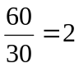 Also 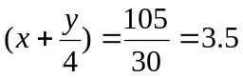or y=6
M.F of the hydrocarbon is C₂H₆ with molecular mass = 2(12) + 6(1) = 30g
(d) Steam Distillation
This is the technique of separating a volatile substance that is immiscible with water from a non-volatile component at a temperature below its boiling point.
This method helps in separating organic compounds that decompose near their boiling point and distil at a temperature below their boiling points.
It uses the principle of
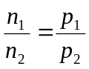 Where n₁ and n₂ are moles of component 1 and 2 respectively with vapour pressure P₁ and P₂ respectively
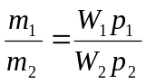 Where W₁ and W₂ are the molecular mass of 1 and 2 respectively
Example
(a) When 4.9g of an organic compound X was burnt in excess oxygen, 14.78g of carbondioxide and 5.38g of steam was formed. Calculate the simplest formula of X
(b) X was steam distilled at 80ºC and 760mmHg and the distillate was found to contain 90.8% by mass of X. The vapour pressure of water at the same temperature is 240mmHg.
(i) Calculate the formula mass of X
(ii) Deduce the molecular formula of X
(iii) Write down the possible isomers of X
Soln:Mass of Carbon =
Mass of Hydrogen=
Elements: C H
Moles: 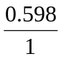
Ratio 1 : 1.667
3 : 5 hence E.F. of X is C₃H₅
(b) (i) From P_{T} =P₁+ P₂ or P₂= 760-240 = 520mmHg and m₁ = 100 - 90.8 = 9.2
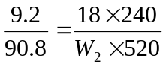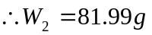
(ii) (C₃H₅) _{n} = 82 or n =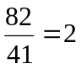M.F of X is C₆H₁₀
(iii) The isomers are 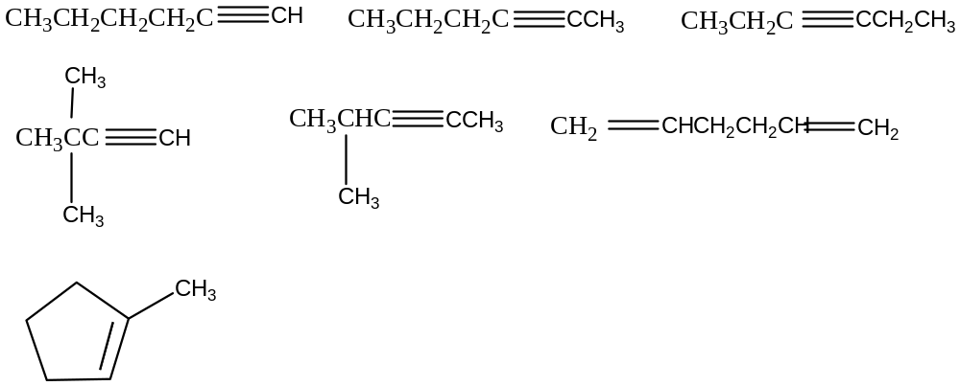
N.B. Check Physical Chemistry Textbook for more questions in order to practice
CHAPTER TWO
ALKANES
These are hydrocarbons which form a homologous series of saturated nature with a general formula C_{n}H_{2n+2}. Successive members differ in composition by a methylene group
The main sources of Alkanes include:
- Natural gas which mainly contains methane with low amounts or propane and butane
- Petroleum products which are separated by fractional distillation during a process of refining
Cracking
This is the breaking down of long chain organic molecules (hydrocarbon) into two or small molecules which are useful products.
Cracking can be done using a catalyst (catalytic cracking) or by using high temperature (thermal cracking), the alkenes are used to make other chemical and alkanes are used for fuels.
NOMENCLATURE/NAMING OF ALKANES
With exception of the first four members of the homologous series, the straight chain members are named by taking prefix appropriate to the number of the carbons and adding the ending –ane.
For branched members, the longest chain is selected and prefix is added to the name of the main of the chain, the position of the substituent is also indicated by appropriate number
Examples
Name the following organic compounds according IUPAC system:
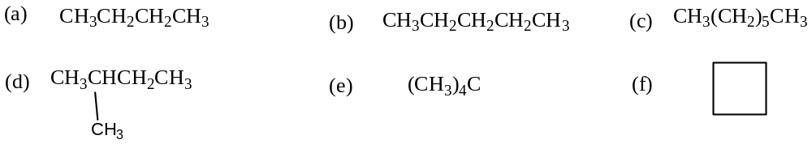
Solution
(a) Butane (b) Pentane (c) Heptane (d) 2-methylbutane
(e) 2, 2-dimethylpropane (f) Cyclobutane
ISOMERISM IN ALKANES
Alkane’s posse’s structural isomers of class chain isomers from Butane.
Example
A hydrocarbon Q has a vapour density of 36 with empirical formula C₅H₁₂.
(a) Determine the molecular formula of Q
(b) Write down the possible isomers of Q and their IUPAC names
Soln:
(a) Molecular mass = 36x2 = 72g
M.F of Q is C₅H₁₂
(b)
PREPARATION OF ALKANES
1. HYDROGENATION OF ALKENES AND ALKYNES
This method provides one of the most suitable methods for preparing Alkanes. It used to deduce the number of the double or triple bond in the unsaturated hydrocarbon.
The method requires catalyst such as Nickel, Platinum or Palladium. Nickel requires an elevated temperature of 150ºC whereas Platinum and Palladium requires ordinary temperature.
This reaction is used to determine the molecular mass of the Alkanes or Alkenes or Alkynes based upon the stoichiometry of the reaction
Example
2.24dm³ of Hydrogen gas at s.t.p reacts with 8.4g of hydrocarbon Q as represented by the equation below:
(a) Identify the functional group in the hydrocarbon Q
(b) Determine the molecular mass of Q hence that of R
(c) Write the:
(i) Molecular formula of Q
(ii) Possible isomers of Q and their IUPAC names
(1 mole of a gas occupies 22.4dm³)
Soln:
(a) Alkenes
(b) Moles of Hydrogen gas reacted =
Moles of the Alkenes = 0.1 (since the mole ratio is 1: 1) hence the RFM = 0.1x8.4 = 84
Molecular mass of Q = 84g
R + 2(12) + 3(1) = 84 thus R = 57g
(c) (i) From the general formula of Alkenes C_{n}H_{2n}
n (12) + 2n (1) = 84 or n = 6 M.F of Q is C₆ H₁₂
(ii)

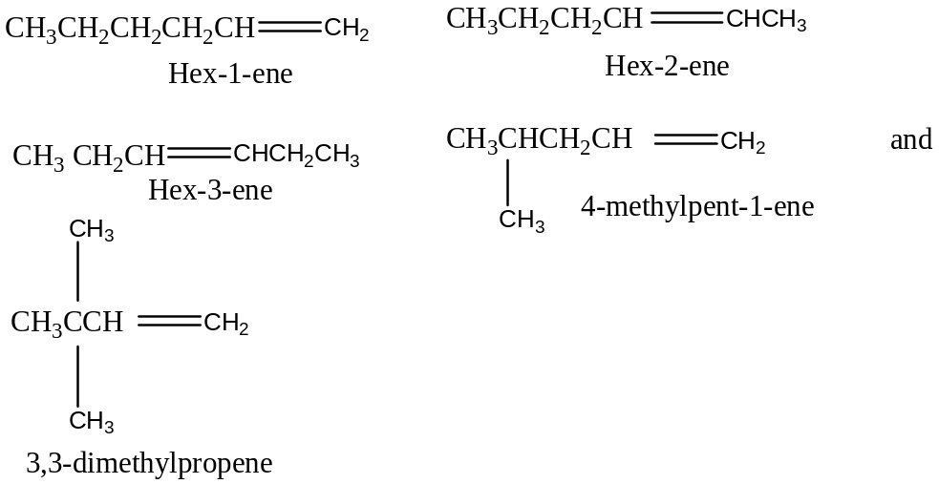

2. KOLBES SYNTHESIS
When aqueous solution of sodium salt of the carboxylic acid is electrolysed, an alkane is liberated at the anode and carbondioxide at the cathode.
This suitable for preparing symmetrical alkane of the R-R .
i.e.
e.g.
3. DECARBOXYLATION METHOD
The sodium salt of the carboxylic acid is heated with soda lime which contains sodium hydroxide and calcium oxide.
This reaction decreases the carbon chain by one carbon
4. FROM ALKYL HALIDES
Reduction of alkyl halides also generates Alkanes. This can be done by using Zinc-Copper couple in ethanol or using lithium aluminium hydride in dry ether.
i.e.
Hydrolysis of Grignard reagent also gives rise to alkane
5. WURTZ REACTION
Haloalkanes react with metallic sodium in dry ether to yield Alkanes of higher molecular mass and the carbons atoms are in even numbers.
Greater yield is obtained when the alkane has a higher molecular mass.
i.e.
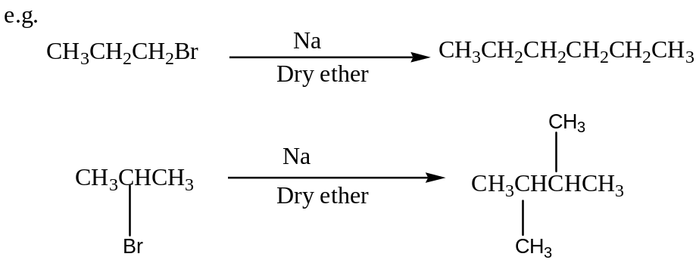
FOR METHANE
Hydrolysis of Aluminium carbide with hot water or dilute mineral acids form methane
Al₄C₃ + 12 HCl 3CH₄ + 4AlCl₃
N.B. The diagonal carbide can also be used i.e. Beryllium carbide
PHYSICAL PROPERTIES OF ALKANES
The straight chainsAlkanes, C₁-C₄ are gases, C₅-C₇ are liquids and the remaining homologues are solids.
Boiling and Melting points increase with increasing molecular mass although the branched isomers are more volatile and degree of volatility increases with branching.
Alkanes are immiscible with polar solvents such as water but soluble in non-polar solvents such as chloroform, ether etc.
Density of the Alkanes increase with molecular mass but the factor reduces with increase in the branching.
REACTIONS OF ALKANES
Alkanes are generally unreactive compared to alkenes and alkynes.
Reasons:
- The C-C and C-H bonds are strong therefore unless heated to higher temperatures or subjected to ultraviolet light.
- Carbon and Hydrogen have nearly the same electronegativity value therefore the bonds are slightly polarized.
- There are no lone pairs of electrons in Alkanes therefore Alkanes are not attacked by acids.
However, under certain conditions, some of the reactions of Alkanes (paraffins) include:
1. COMBUSTION
Alkane’s burn in excess oxygen to form carbondioxide and water,the reaction is exothermic and it can be used to determine the molecular formula of the Alkanes.
2. CHLORINATION OR BROMINATION
Alkanes react with halogens when heated at 250-400oC or in presence of Ultraviolet light to form a mixture of products which are difficult to separate.
The reactivity is the order of Fluorine> Chlorine> Bromine> Iodine. Iodine does not react with Alkanes while Fluorine reacts explosively.
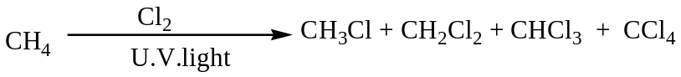
Mechanism
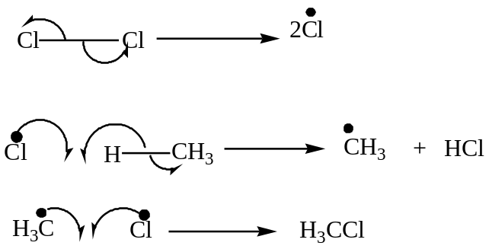
N.B. The reaction mechanisms repeat to generate the rest of the products.
3. NITRATION REACTION Alkanes react with nitric acid at about 400ºC via free radical mechanism to form nitro- alkane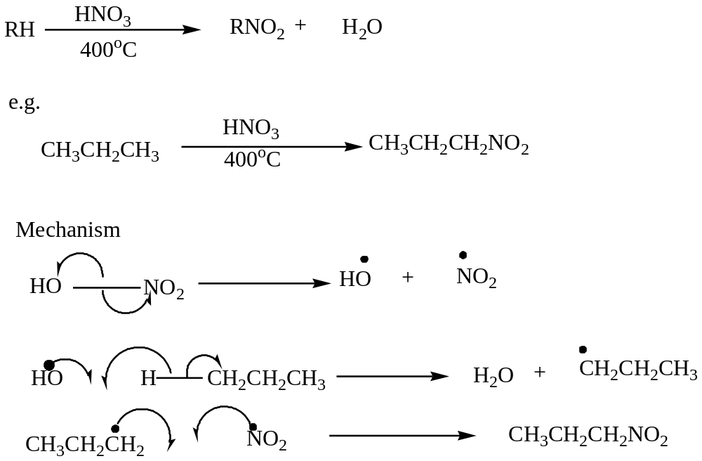

4. HALOGENATION USING SULPHURYL CHLORIDE
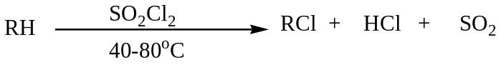
CHAPTER THREE
ALKENES (OLEFINS)
Alkenes form a homologous series of unsaturated hydrocarbons containing a carbon-carbon double bond with the general formula C_{n}H_{2n} .
NOMENCLATURE OF ALKENES
In accordance with the IUPAC system, an alkene is named by dropping the ending ane from the corresponding alkane and replacing it with suffix ene.
Where required, the position of the double bond is specified by appropriate number between the stem name and ending ene except for ethene and propene without positional isomers
Example
Name the following organic compounds using the IUPAC System:
Solution:
(a) Propene (b) But-1-ene (c) But-2-ene (d) 2-methylpropene
(e) 2-methylpent-2-ene (f) 2, 3-dimethylhex-2-ene
Question
(a) Draw the structure of the following organic compounds:
(i) 3, 3-dimethylcyclopentene (ii) 6-bromo-2, 3-dimethylpent-2-ene (iii) 3, 6-dimethyloct-3-ene
(iv) 5-bromo-4-chlorohept-1-ene (v) 4-ethyl-3-methylcyclohexene
(b) Name the following organic compounds:
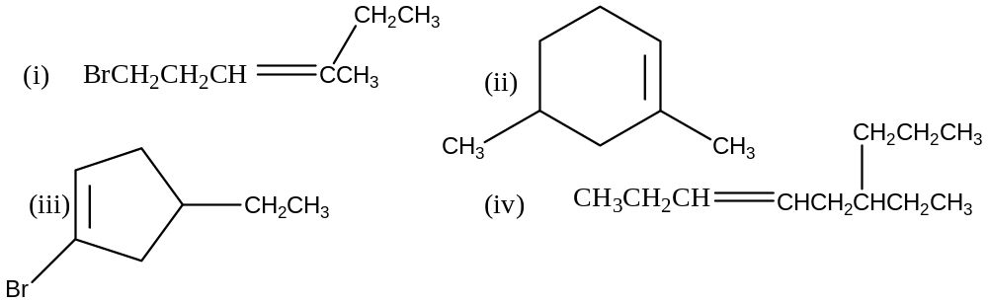
SYNTHETIC PREPARATIONS OF ALKENES
Alkenes are generally prepared by elimination of one atom or groups from two adjacent carbon atoms mainly from alcohols and halo alkanes.
The ease of dehydration of alcohols is: 3º Alcohol> 2º>1ºAlcohol while the ease of dehydrohalogenation of halo alkanes is 3º> 2º>1º

FROM ALCOHOLS
Alcohols are heated with excess concentrated sulphuric acid or orthophosphoric acid. The temperature of dehydration depends on the structure of the alcohol.
The reaction involves removal of water molecules hence known as dehydration reaction
The 1º and 2º Alcohols following the same mechanism while 3º Alcohols undergoes partial ionization generating 3ºCarbocations
Example
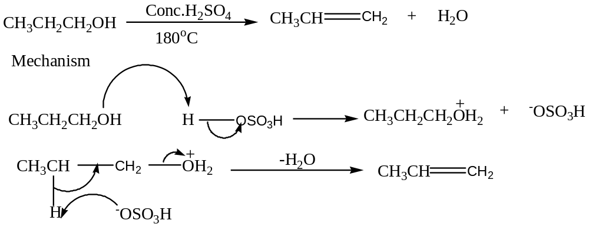

Example
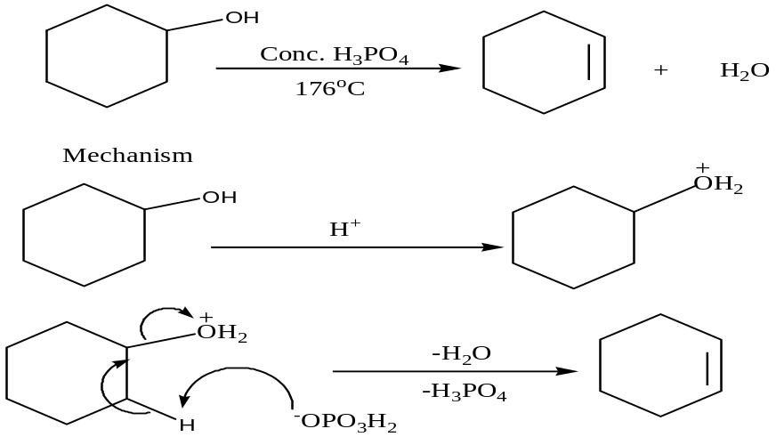
Example
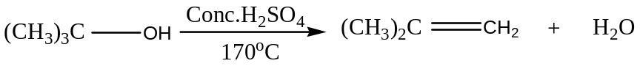
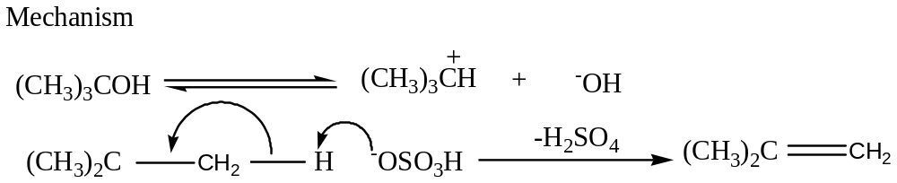
Example
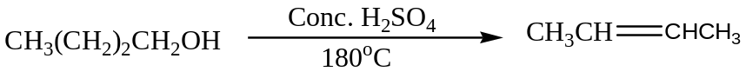
Write the mechanism of the above reaction.
2. FROM HALOALKANES
Halo alkanes are heated with a strong base to generate an alkene.
(i) Dehydrohalogenation of alkyl halides.
Halo alkanes are heated with a strong base such sodium amide in liquid ammonia or sodium ethoxide in ethanol in order to remove hydrogen halide i.e.
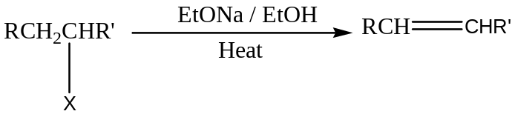
Example
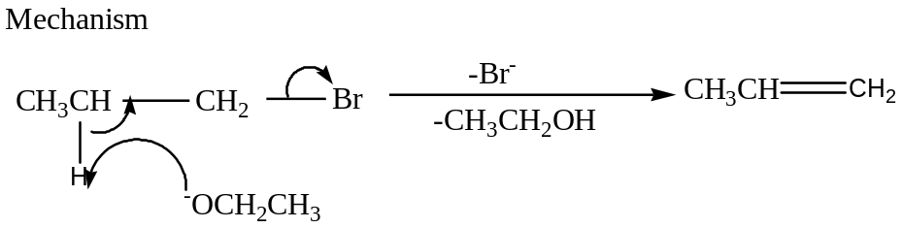
Example
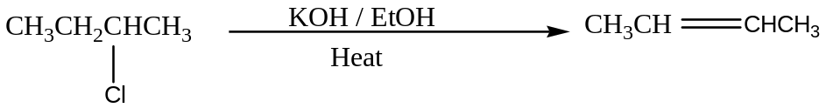
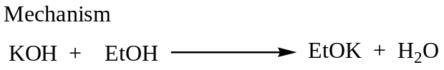
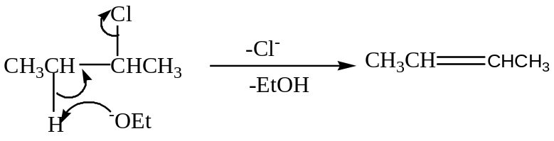
Example
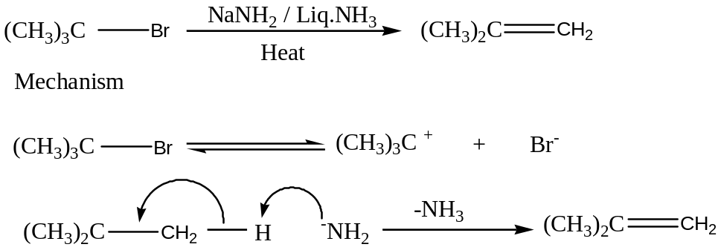
(ii) Dehalogenation of Vicinal dihalides
When vicinal dihalides are heated with Zinc, alkenes are formed i.e.
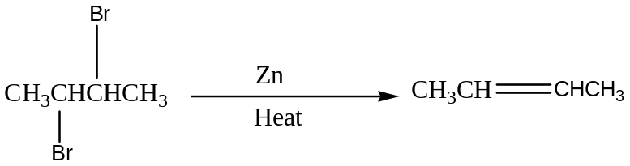
N.B. On a large scale, alkenes are obtained by cracking of petroleum products
REACTIONS OF ALKENES
Alkenes undergo Electrophilic addition since they are electron rich species.
Some of the addition reactions include:

1. ADDITION OF HYDROGEN
Hydrogenation of alkenes generate alkanes
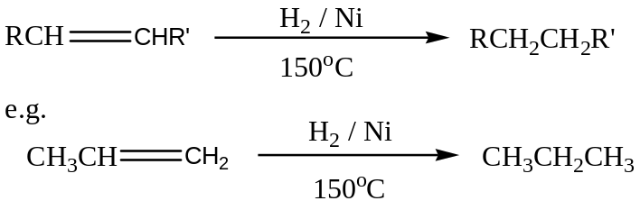
2. ADDITION OF HALOGENS
This reaction is usually carried out in an inert solvent such carbon tetrachloride. Chlorine and Bromine reacts but Iodine fails to react.
The reddish- brown colour of bromine is turned colourless therefore the reaction is used to test for presence of carbon-carbon double bond and the number of double bonds since the mole ratio is 1:1(Alkene : Bromine )
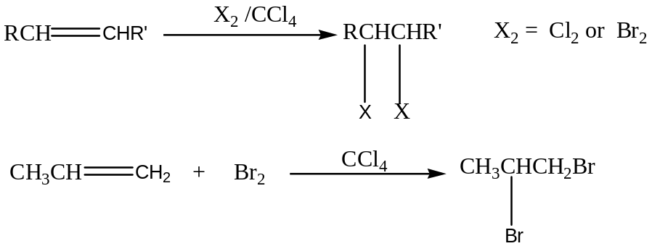
Mechanism
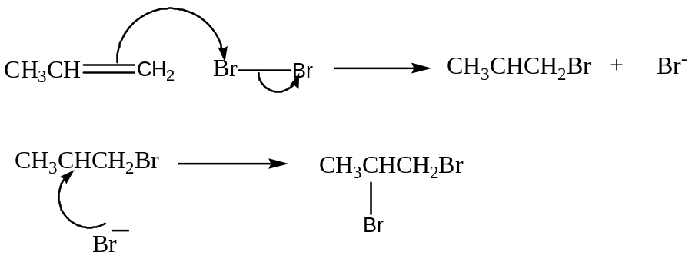
3. HALOHYDRIN FORMATION
Bromination or Chlorination of alkenes in water generates bromoalcohol or chloroalcohol
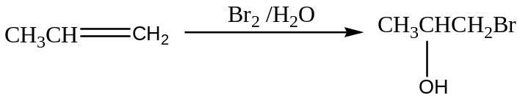
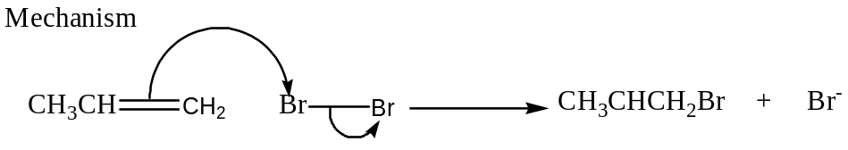
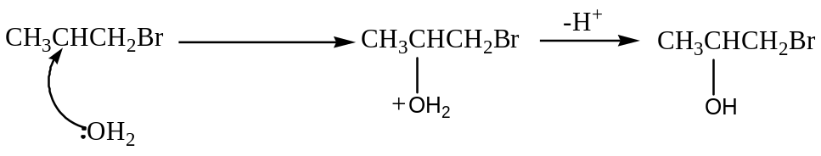
N.B. The mechanism is the same when chlorine water is used.
4. ADDITION OF WATER / HYDRATION
Alkenes react with cold concentrated sulphuric acid to form alkyl hydrogen sulphate which reacts with water on heating alcohol
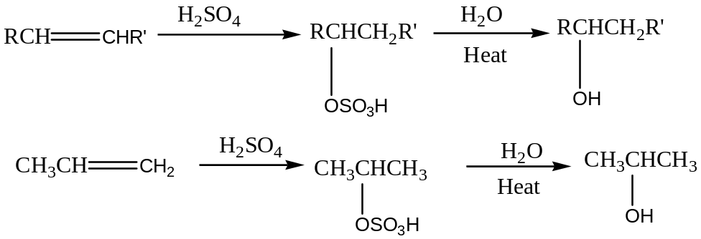
Mechanism
The mechanism follow markovnikov rule.
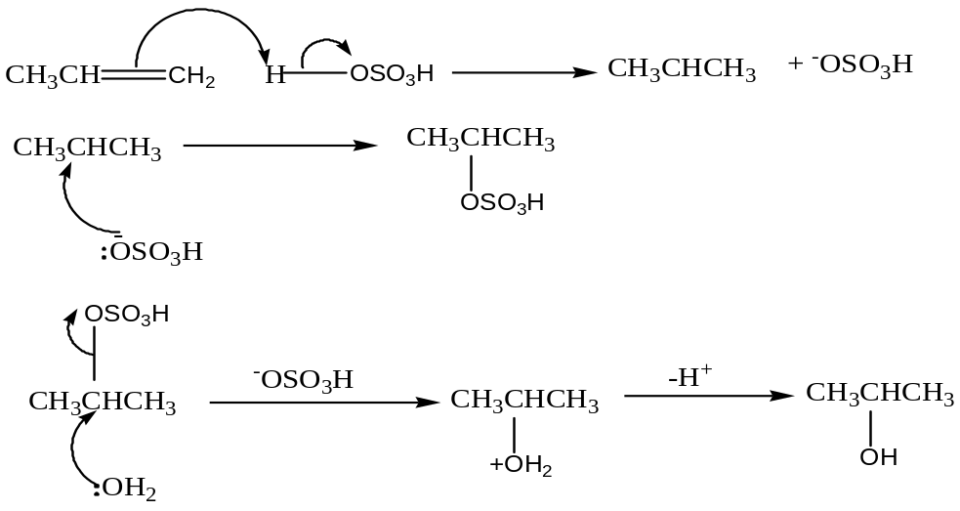
5. ADDITION OF HYDROGEN HALIDES
Hydrogen halides react with alkenes forming alkyl halides.
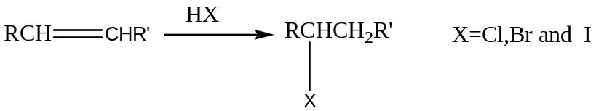
In the reaction above, the hydrogen atom from hydrogen halide adds itself to the carbon atom of the double bond with the larger number of hydrogen atoms.
Also the halogen adds itself to the carbon atom in double bond with lower number of hydrogen atom thus these are known as Markovnikov rule.
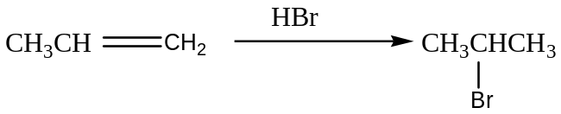
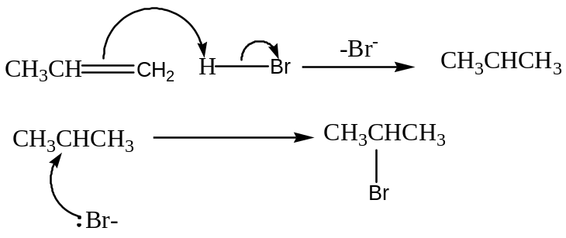
Example
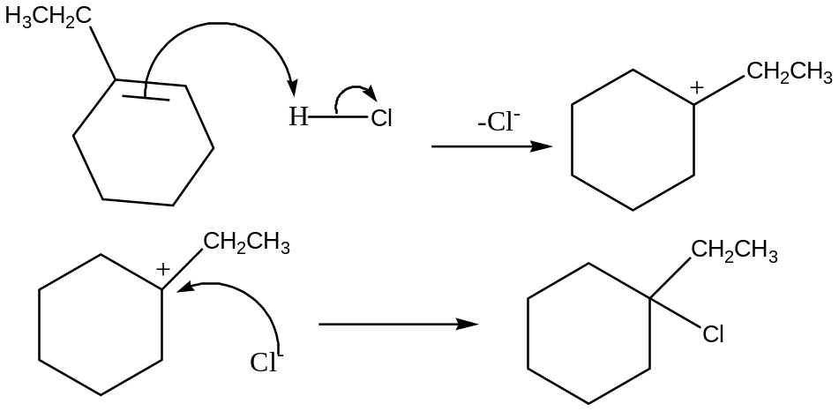
N.B. The hydrogen bromide are usually generated by action of concentrated Sulphuric acid on sodium bromide
6. ADDITION OF HYDROGEN BROMIDE IN PRESENCE OF PEROXIDE
In this reaction, the bromine atom adds itself to the carbon atom of the double bond having higher number of hydrogen atoms with hydrogen atom (from Hydrogen bromide) to lower carbon atom.
This observation is known as anti-markovnikov rule.
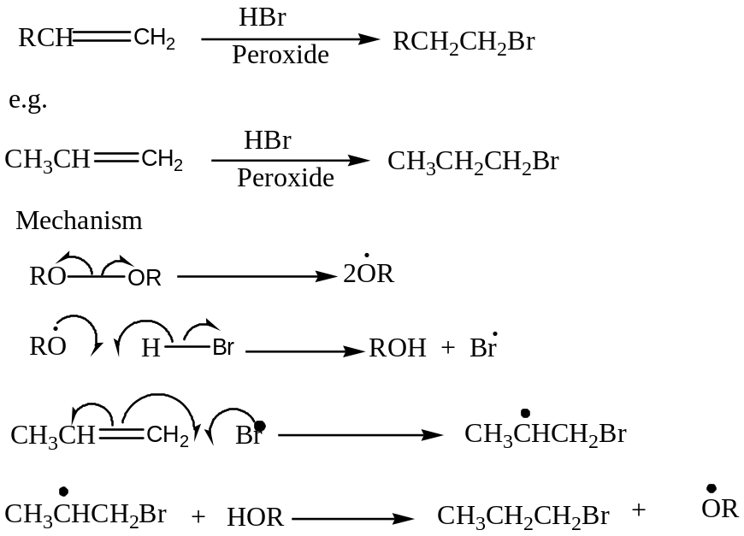
7. WITH ALKALINE POTASSIUM MANGANATE (VII). Manganate (VII) is a weak oxidising agent therefore it oxidizes alkenes to diols. The purple colour turns colourless.
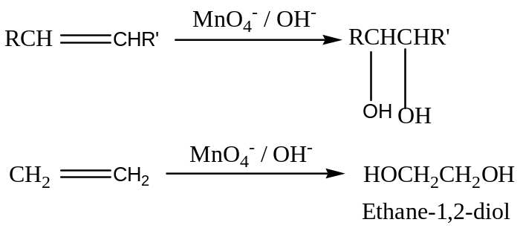
The reaction is also used to test for unsaturated compounds. It can also occur if the reagent is in acidic medium.
8. OZONOLYSIS
Alkenes react with ozone to form ozonide which on hydrolysis generates carbonyl compounds.
The reaction is used to determine the structural formula of the alkene.
Alkenes with terminal double bond form methanal (HCHO), those with structure RCH= form Aldehydes (RCHO) while those of structure RR’C= form Ketones. i.e
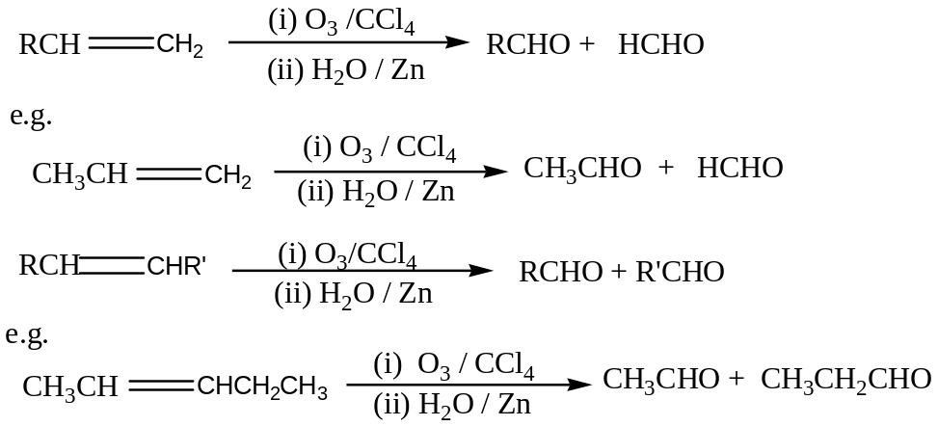
N.B. Ozonolysis is the formation of ozonide followed by hydrolysis to generated carbonyl compounds.
8. POLYMERISATION REACTION
Alkenes undergo addition polymerization to form polymers.
Ethenepolymerises to form polyethene which is an important plastic material used as packing material.
Sample Question
A hydrocarbon A contains 87.8% carbon. Its relative molecular mass is 82. A decolorizes bromine and in presence of Nickel it reacts with hydrogen to form B. 0.1g of A was found to absorb 27.3cm³ of hydrogen (measured at s.t.p). B does not decolorize bromine.
(a) Determine the:
(i) Empirical formula
(ii) Molecular formula of A.
(b) Calculate the:
(i) Number of moles hydrogen that reacted with one mole of A
(ii) Number of double bonds in the molecule of A
(c) Write the possible Isomers of A.

CHAPTER FOUR
ALKYNES OR ACETYLENES
Alkynes are unsaturated hydrocarbons having a triple bond between carbon atoms. The general formula of the homologous series is C_{n}H_{2n-2.}
NOMENCLATURE OF ALKYNES
The IUPAC names of the alkynes are obtained by taking the corresponding alkane name and replacing the ending with suffix” –yne”.The position of the triple bond is indicated by inserting the appropriate number between the stem and the ending”–yne”
Question:
Name the following organic compounds using the IUPAC system.
PHYSICAL PROPERTIES
The physical properties of alkynes are similar to those of alkanes and alkenes; however they boil at a higher temperature than alkenes and alkanes with the same number of carbon atoms due short bond length.
Alkyne | Bpt (ºC) | M.p.t (ºC) | Alkene | B.p.t (ºC)
Ethyne | -75 | -82 | Ethene | -104
Propyne | -23 | -101.5 | Propene | -47
But-1-yne | 9 | -122 | But-1-ene | -6.3
Hex-1-yne | 72 | -124 | Hex-1-ene | 63

Synthetic Preparation
Alkynes are usually prepared by dehydrohalogenation of dihalogencompounds.
The dihalogen compounds are heated using strong bases which include:
- Sodium ethoxide in ethanol
- Sodium amide in liquid ammonia ( solution of sodium in liquid ammonia)
- Potassium hydroxide in ethanol (contains ethoxide ions but not aqueous Potassium hydroxide or aqueous sodium hydroxide)
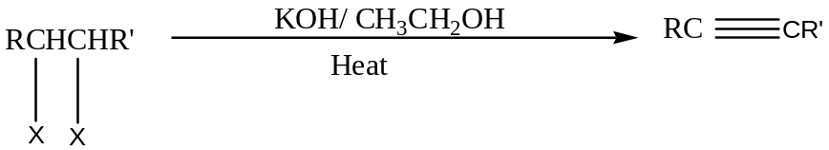
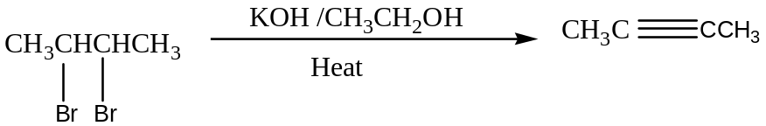
Mechanism
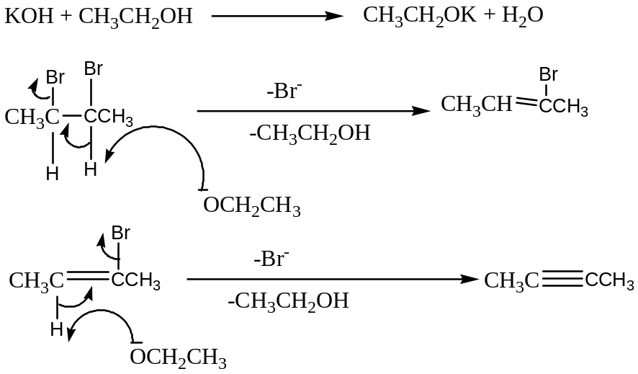
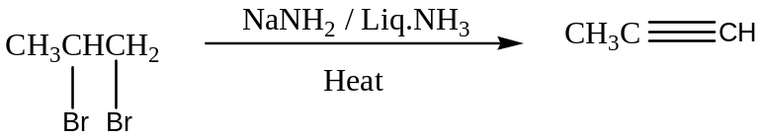
Qn: Write the mechanism of the reaction above.
Note: The dihalogen compounds are prepared by:
(a) Bromination or Chlorination of Alkenes

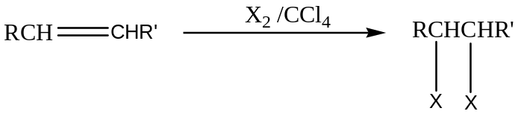
(b)Carbonyl compounds
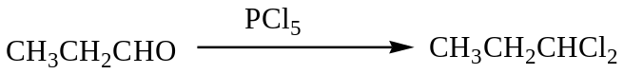

INDUSTRIAL PREPARATION OF ETHYNE
(a) Treatment of Calcium dicarbide with water
Calcium dicarbide is obtained by reducing Quicklime, obtained from Limestone, with coke in electric furnace 2000-3000ºC
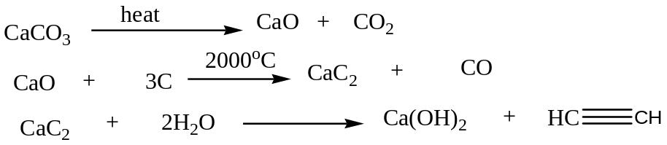
(b) Partial combustion of Methane
In this method, ethyne is separated by passing the gases product through Propanoneor Ammonia
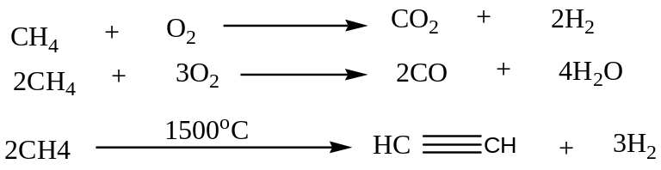
REACTIONS OF ALKYNES
Just like Alkenes, Alkynes also undergo Electrophilic addition due to availability of loosely held 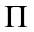 electron. Addition of hydrogen, Halogens and Hydrogen halide to alkynes is very much like addition to alkenes except that here two molecules of reagent can be consumed.
- Addition of hydrogen
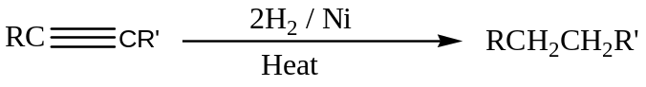
- Addition of Halogens
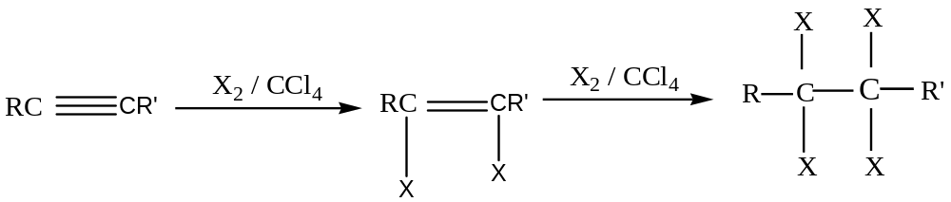
X₂ = Cl₂ or Br₂
Qn: Write the mechanism of the above reaction
- Addition of Halogen halides
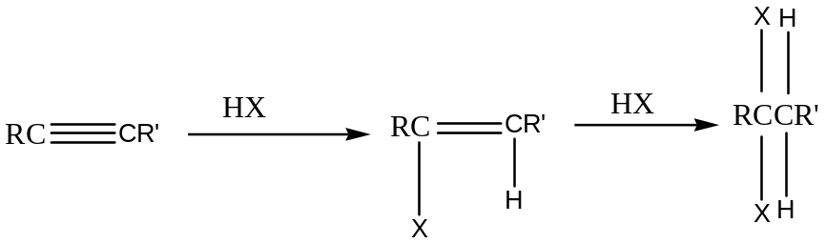HX= HCl, HBr and HI
Qn: Write the mechanism of the above reaction
- Addition of hydrogen Bromide in presence of peroxides
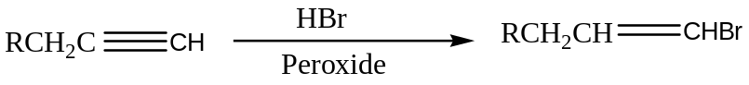
This reaction resemble that of alkenes to generate anti-markovnikov product
- Addition of water. Hydration
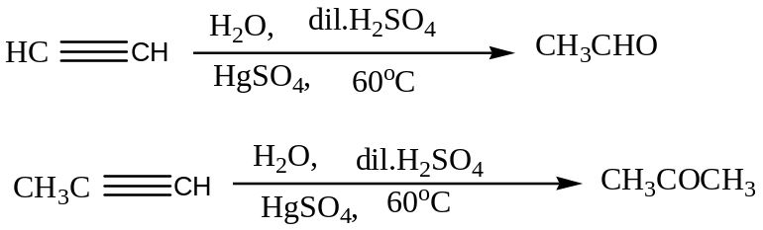
Ethyne is the only alkyne that forms Aldehydes (ethanal) while the rest form Ketones on hydration.
- Polymerization of Ethyne
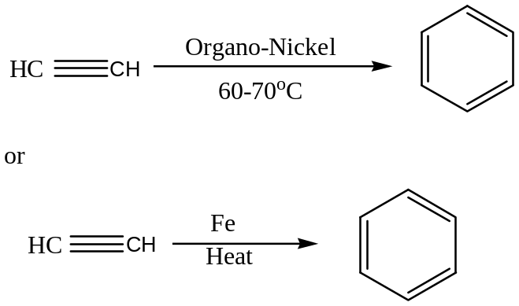
- Substitution reaction of Acidic Hydrogen
Alkynes which have a triple bond at the end of the chain (terminal alkynes) have a replaceable acidic hydrogen atom.
- With Ammoniacal Silver nitrate Solution
Terminal Alkynes react to form white precipitate.
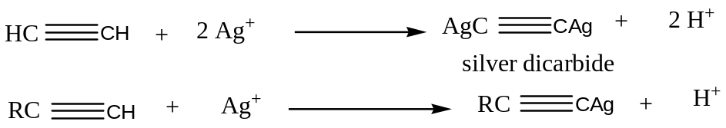
This reagent is used to differentiate terminal alkynes from Non-terminal alkynes
- With Ammoniacal Copper (I) Chloride solution
Terminal Alkynes react to form red precipitate 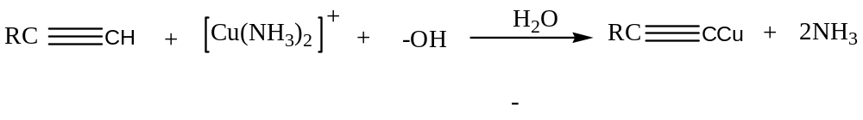
Also, ammoniacal copper (I) chloride solution is used to differentiate terminal alkynes from non-terminal.
- Sodium Acetylide formation
Terminal Alkynes react with sodium in liquid ammonia to form sodium acetylide which can be used to synthesize the higher homologue by reacting with alkyl halides.
Sample Question
(a) Write equation(s) to show how the following compounds can be synthesized .In each cases indicate the mechanism for the reactions where possible.
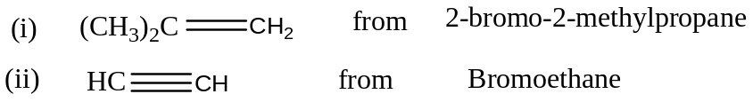
(b) Name the reagent(s) that can be used to differentiate between the following compounds. In each case, state what would be observed if the reagent is treated with compounds
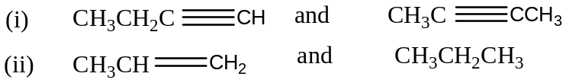
When 400cm³ of the mixture of ethane and ethyne measured at room temperature was bubbled in to mixture of aqueous ammonia and silver nitrate solution. 2.4g of a white solid was formed.
(i) Write an equation for the reaction that took place and name the white solid
(ii) Calculate the percentage by volume of ethane in the mixture
(d) (i) Define the structural isomerism
(ii) Using suitable example(s), State the classes of structural isomerism

CHAPTER FIVE
AROMATIC HYDROCARBONS- BENZENE
Introduction
In the last chapter, we considered unsaturated compounds-Alkenes and Alkynes. There is another important class of unsaturated compounds that needs to be considered separately because their properties are so different from those of alkenes and alkynes.
This class of compounds is called the Aromatic hydrocarbon and its simplest member is Benzene.
The name Aromatic was originally used because some derivatives of these hydrocarbons have pleasant smells. Its is now known that just many of them have unpleasant and in any case the aromatic vapours are toxic
Therefore the name Aromatic has been retained to indicate certain chemical characteristics rather than odorous properties.
The structure of Benzene
Since 1834, molecular mass determination generated the molecular formula of benzene as C6H6. The exact structural formula, however posed a problem for many years.
With such a high ratio of C: H, benzene must be a highly unsaturated with a possible structure of hexatetraene e.g.
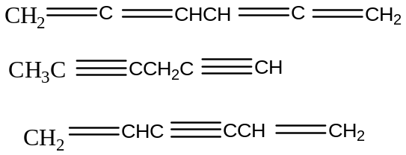
However, benzene does not undergo addition reactions across the double bond as alkenes therefore Kekule (1865) proposed a ring structure in which alternate carbon atoms were joined by double bond as:
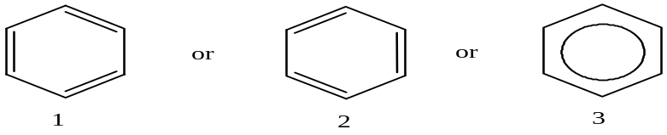
Bond lengths
X-ray diffraction studies show that benzene is planar and all the C-C bonds are the same.
Some of the bond lengths are:
C-C bond length in all bonds in benzene, 0.139nm
C-C bond length in cyclohexane, 0.154nm
C-C bond length in cyclohexene, 0.133nm
Kekule model would suggest unequal carbon-carbon lengths, alternating between double and single bond values. In fact the constant bond length is found between single and double bond.
Question: Explain the variation in the bond length between cyclohexane, cyclohexene and benzene.
Soln: From Molecular orbital terms, Benzene is a planar molecular with all the six hydrogen and six carbon atoms lying in the same plane. Each Carbon atom is sp2 hybridized and explains why structure 3 is preferred.
Also, the variation can be attributed to resonance energy which indicates than benzene is more stable than cyclohexene and all carbon –carbon bond lengths in benzene are equal.
Thermochemistry of Benzene
Benzene is more stable than expected and this is illustrated using the enthalpy of hydrogenation to cyclohexane. i.e.
The enthalpy of hydrogenation of cyclohexene is -119KJ/mol
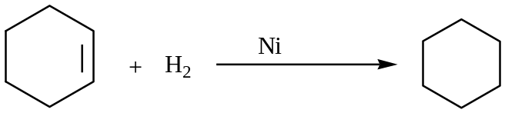 ∆H= -119KJ/mol
Considering Benzene as Cyclohexa-1, 3, 5-triene which has three double bonds then, we expect its enthalpy of hydrogenation to be = 3 (-119) = -357KJ/mol.
However, the experimental value observed was = -207KJ/mol.
The difference in the values (-357 + 207) = -150KJ/mol and it indicates that Benzene is more stable than cyclohexa-1, 3, 5-triene. The difference in the values is known as Resonance or Delocalization energy
Sources of Benzene
Benzene is obtained from petroleum oil by fractional distillation.
Synthetic Preparation
Owing to the great abundance of Benzene from Industrial sources, it is rarely prepared but may be prepared by the following methods.
1. Decarboxylation of Sodium Salts
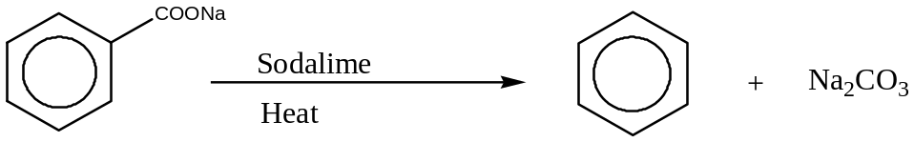
2. Reduction of Phenol
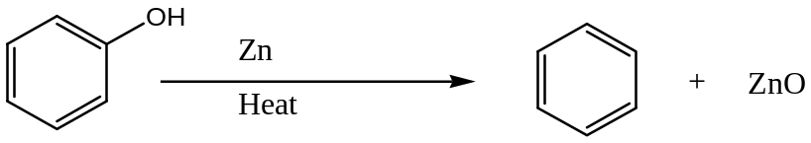
3. Polymerization of Ethyne
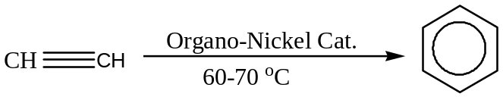
Physical properties Of Benzene
Benzene is a colourless liquid with a characteristic Aromatic smell. It is immiscible with water but highly soluble in organic solvents as well as being used as solvent itself.
Like all Aromatic compounds, it burns with a sooty flame owing to its relatively high carbon content
Reactions of benzene
The availability of the pie electrons in benzene serves as a source of electrons which are donated to electron deficient species (Electrophiles). The reactions therefore are characterized by Electrophilic substitution reactions which differ from Addition reactions of Alkenes.

1. Nitration reaction
This is the reaction of Benzene with nitrating mixture containing equal molar quantities of concentrated Nitric acid and sulphuric acid.
In this reaction, the hydrogen atom is substituted by a nitro group to generate Nitrobenzene.
Concentrated Sulphuric acid is used to protonate weaker Nitric acid such that Nitroniumcation is produced.
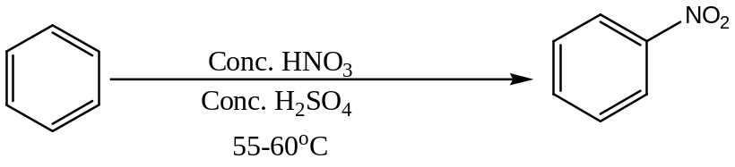
Mechanism
Nitrobenzene is used to produce Phenylamine (Aniline) by reduction process which is used to manufacture azo-dyes.
An example of an azo-dye is 4-hydroxyazobenzene which is orange solid synthesized from Nitrobenzene as shown below.
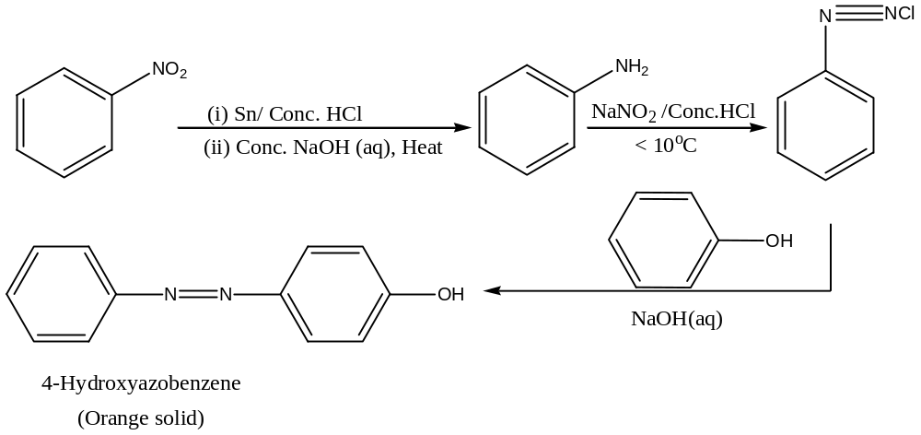
2. Sulphonation reaction
This is carried out by using fuming sulphuric acid. Concentrate sulphuric acid can be used but requires refluxing for several hours.
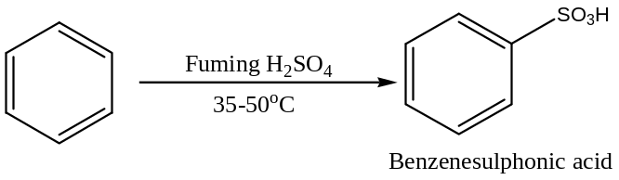
Mechanism
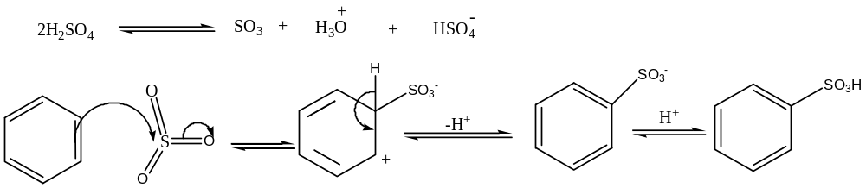
N.B The overall reaction is reversible with the equilibrium tending to the left.
BenzeneSulphonic acid is used in the manufacture of phenol.i.e.
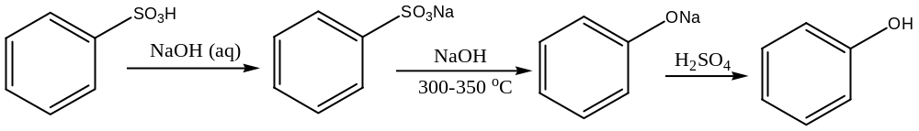
3. Halogenation
Substitution by chlorine or bromine takes place readily at room temperature in presence of halogen carriers’ e.g iron, aluminium chloride or iodine. Iodine does not easily substitute.
The halogen carrier functions as a Lewis acid inducing a certain degree of polarity in the halogen molecule.
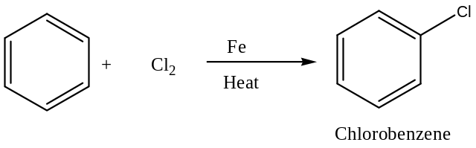
Mechanism
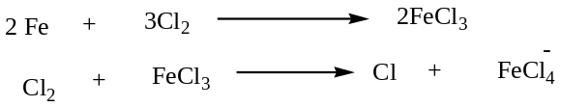
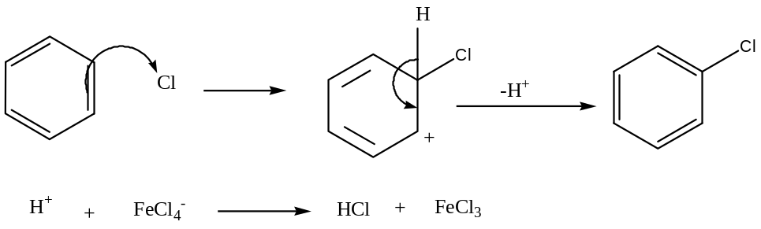
N.B. Bromine in presence of Iron (III) bromide follows the same mechanism.
Qn. Complete the reaction below, name the major product and write the acceptable mechanism of the reaction.
4. Friedel -Crafts Alkylation
Benzene reacts with alkyl halides in presence of Aluminium halides as Lewis acid to form alkyl benzene.
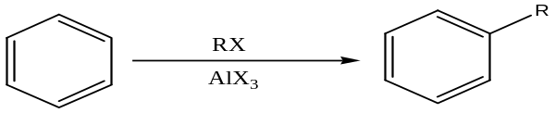
Example
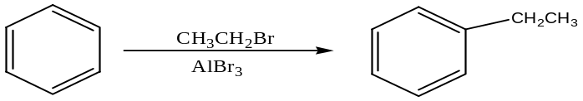
Mechanism
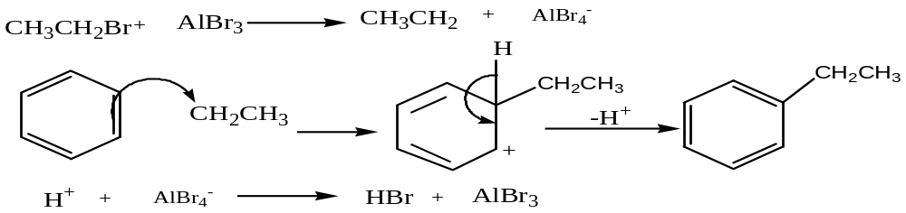
The Haloalkanes can be replaced by other compounds such as Alkenes and Alcohols e.g
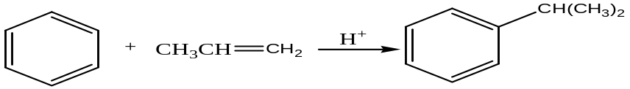
Mechanism
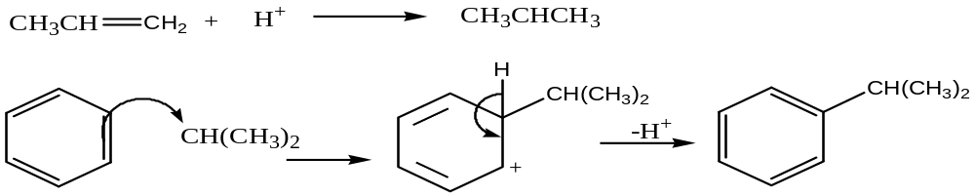
N.B. The alkyl group can be oxidized to carboxylic acid by Acidified KMnO₄ or dilute nitric acid
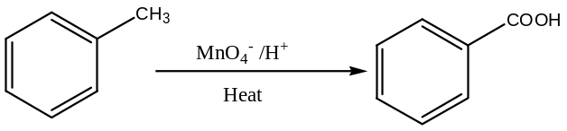
5. Friedel-Crafts Acylation
Acid Halides react with Benzene in presence of Aluminium Chloride to generate Aromatic Ketones.
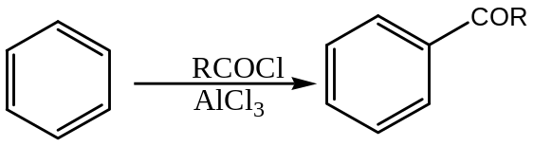
Example
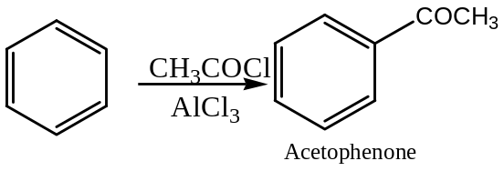
Mechanism
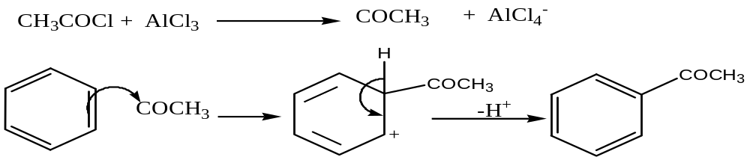
N.B. Acid anhydrides i.e. (RCO)₂O are generally preferred because they are easily obtained in a state of high purity, is more easily handled and resulting Ketones is more easily separated by distillation
Other Important Addition reactions of Benzene include:
1. with Hydrogen
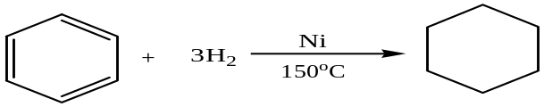
2. with Chlorine
Like Alkanes, Benzene undergo Addition reaction with chlorine in presence of sunlight or Ultraviolet radiation to form 1, 2, 3, 4, 5, 6-hexacyclohexane. 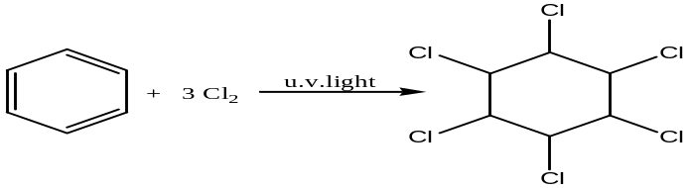
Position of Substitution in Benzene Derivatives
When a second atom or group of atoms is attached to monosubstituted benzene, the position of substitution is determined by the nature of the substituent already attached.
In fact, any substituent group attached to a benzene ring affects the rate and position at which further substitution occurs.
The position of substitution of the second substituent is governed largely by whether or not the atom or group already present is donating electrons to the ring or withdrawing electrons from it.
Electron-donating groups enhance the availability of the pie electrons hence it activates the ring generating products at position 2-(ortho) and 4-(Para).
Examples of electron-donating groups include:
Example of substitution reaction with electron-donating group includes.
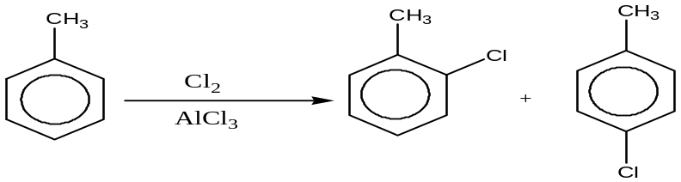
Presence of halogens on the benzene ring deactivates the ring to products at positions 2- or 4- on substitution.
Electron- withdrawing groups reduce the availability of the pie-electrons hence deactivate the ring therefore on substitution position 3- preferred.
Examples of electron-withdrawing groups include:
Example includes:
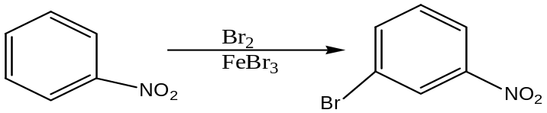
Question
(a) Complete the following reactions and in each case write the acceptable mechanism;
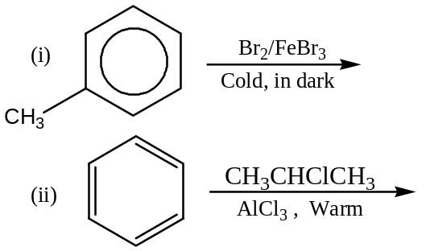
(b) How would distinguish between the following members of the pairs of compounds. In each case, state what would be observed when the reagent is treated with each member of the series.
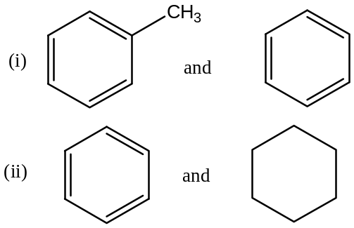
(c) Write equation(s) to show how the following compounds can be synthesized. In each case , indicate the condition(s)/reagent necessary.
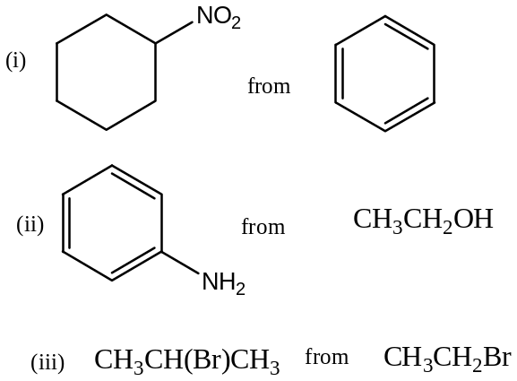

CHAPTER SIX
HALOHYDROCARBONS
Introduction
Organic halogen compounds are halogen derivatives of alkanes. Monohalo derivatives (Alkyl halides) have a general molecular formula C_{n}H_{2n+1} X (X= Cl, Br and I). Fluorine is excluded because C-F bond is strong due to high electronegativity therefore C-F bond is unreactive.
Consequently fluorocarbon compounds are extremely inert and non-flammable.
Alkyl halides are divided into three classes depending on the number of the alkyl groups attached to the carbon atom bonded to the halogen i.e.
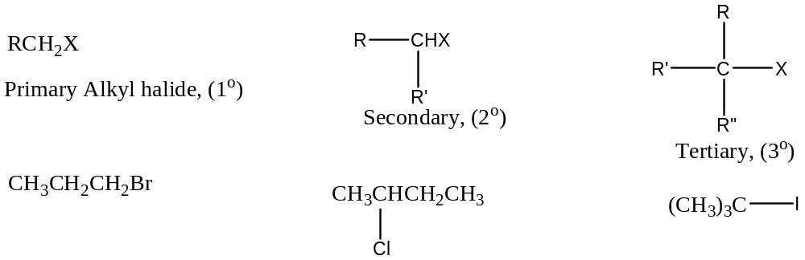
Aryl halides are halogen compounds in which the halogen atom is directly attached to the aromatic ring (Benzene). They are generally represented as ArX e.g.
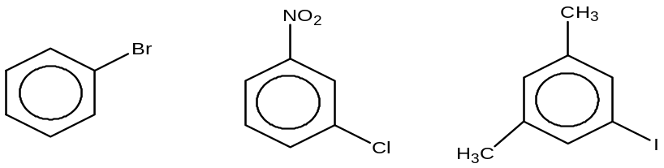
If two halogen atoms are attached to adjacent carbon atom, the alkyl dihalides is known as Vicinal Dihalides while if are attached to the same carbon then it is known as germinal dihalides.
N.B Vinyl halides are compounds in which halogen is attached to a doubly bonded carbon e.g chloroethene while aryl halides are unsaturated halogen compounds.
Nomenclature
Organic halogen compounds are named using the prefixes fluoro, chloro, bromo or iodo-. Numbers are used to indicate the position of the halogen atom in the carbon containing molecule.
Example
Name the following organic compounds
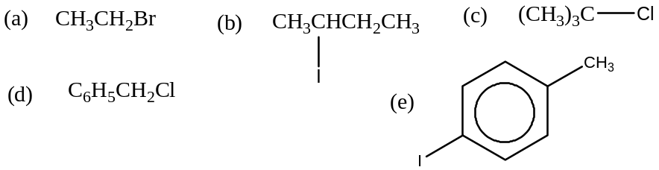
Soln:
(a) Bromoethane (b) 2-iodobutane (c) 2-chloro-2-methylpropane (d) Chloromethylbenzene
(e) 4-iodomethylbenzene
Synthetic Preparation
For Alkyl halides:
1. From Alkenes
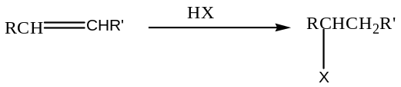
(See Alkenes for mechanism and detailed position for addition product)
2. From Alcohols
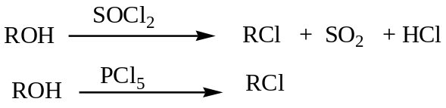
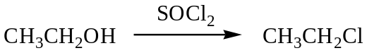
3. From Alkanes
Substitution with halogens in presence of sunlight or ultraviolet light is not suitable method since it generates a mixture of products.
For Aryl Halides
1. From Diazonium salt
The salt is warmed with appropriate copper (I) halide e.g.
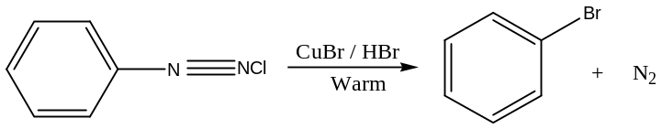
2. Direct Halogenation of Benzene
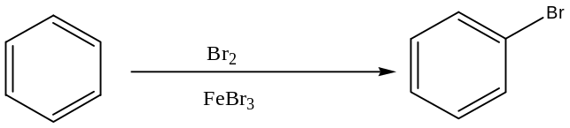
(See Benzene for Mechanism and other halogen and Halogen carriers)
Physical Properties
Because of the polarity of the carbon-halogen bond due to electronegativity difference which enhances dipole-dipole interaction in liquid phase, Haloalkanes have a higher boiling point than alkanes of comparable molecular mass.
Most Haloalkanes are liquids (except Iodomethane) and their boiling points depend on the alkyl group and halogen atom. Fluoroethane and chloroethane are gases.
For corresponding halogen atoms, boiling points increases with increasing molecular mass. Densities decreases in the same order due to close packing of smaller molecules in the liquid phase.
Haloalkanes and Aryl halides are both insoluble in water but soluble in organic solvent due to inability to form hydrogen bonds with water.
Reactions
The Haloalkanes are fairly reactive compounds due to polarity of the Carbon-halogen bonds therefore the electron deficient carbon atom is susceptible to attack by electron rich species hence their reactions are characterized by Nucleophilic substitution reactions.
Some of the Nucleophilic substitution reactions include:
1. Ether Formation
This reaction provides the suitable method for preparation of alkoaromatics and alkoalkanes.
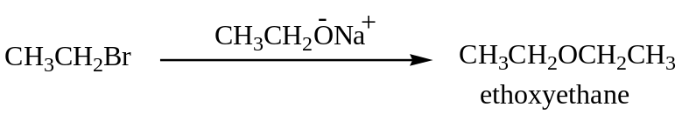
Mechanism
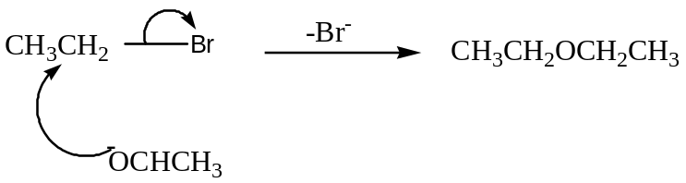
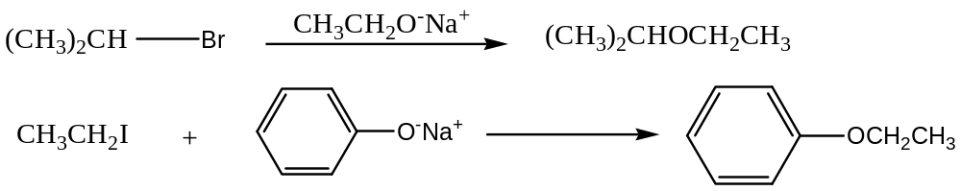
Write the mechanism for the above reactions.
N.B. Sodium or Potassium Alkoxideare prepared by dissolving alkali metal in the excess appropriate alcohol.
2. Ester Formation
If the haloalkane is warmed with alcoholic solution of silver salt of carboxylic acid, an ester (sweet fruity smell) is formed. Silver halide is precipitated.
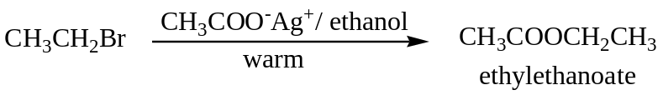
Mechanism
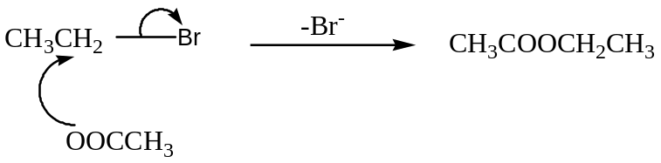
The reaction cannot be used to generate phenyl esters.
N.B. A solution of Silver ethanoate in ethanol can be used to distinguish Haloalkanes from Acryl halides.
3. Amine Formation
When concentrated Ammonia solution is heated when Haloalkane in a sealed tube, different classes of amines are generated.
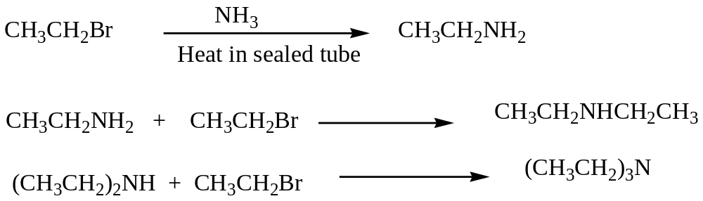
To generate Primary amine, excess ammonia is used.
The reaction is limited to haloalkanes although aryl halides react if electron-withdrawing groups are present in 2- or 4- positions.
4. Cyanide (Nitrile) Formation
When heated, haloalkanes react with potassium cyanide in an alcohol to generate alkanenitrile.
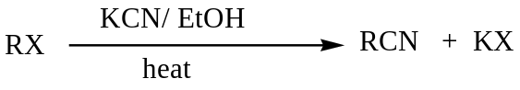
Example
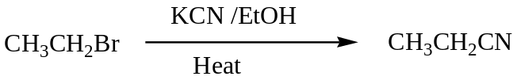
Mechanism
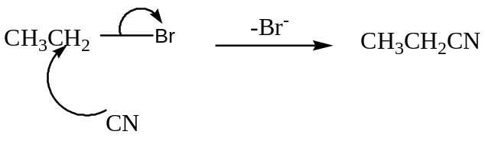
Aromatic nitriles are not prepared from aryl halides but from benzene Diazonium salts. i.e
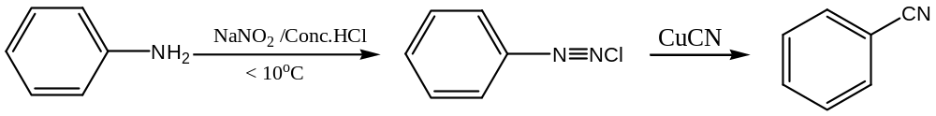
Alkanenitrile are usually used to generate carboxylic acid of higher carbon chain. i.e.
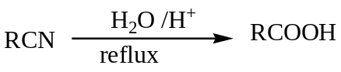
Example
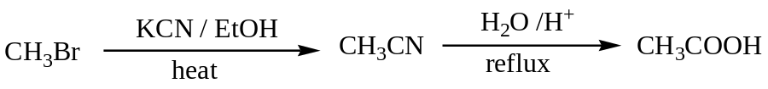
5. Higher Alkyne formation
Haloalkanes react with sodium salt of acidic alkyne to form higher non-terminal alkynes.
6. Grignard Reagent Formation.
Both haloalkanes and Aryl halides react with Magnesium in presence of dry ether to generate Grignard reagent.
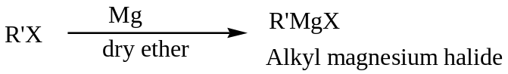
The reagent is widely used to generate alkanes, alkenes, alkynes, alcohols, Aldehydes, Ketones and carboxylic acid.
For Alkanes:
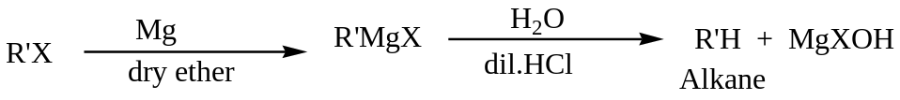
For Alcohols:
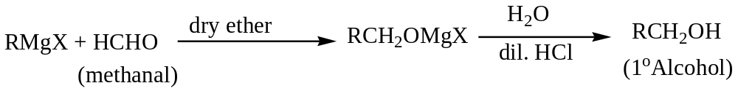
Example:
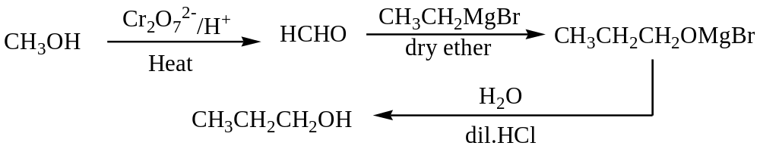
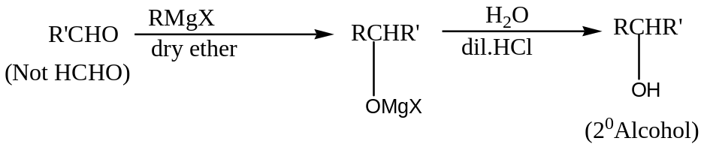
Example
Write equations showing how Propene can be converted to Butan-2-ol.
Sol: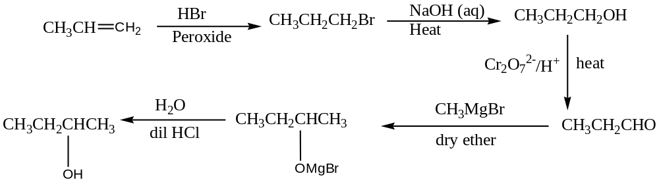
Example
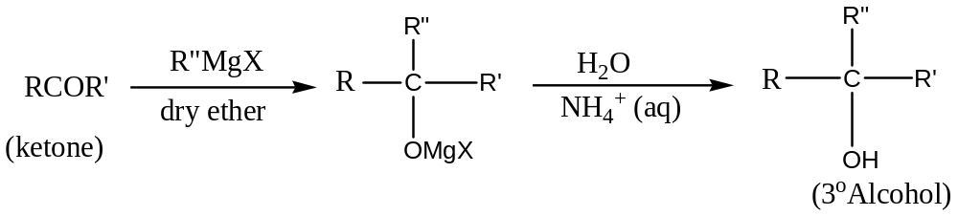
N.B. Aqueous Ammonium salt is used in hydrolysis to generate 3ºAlcohol because the acid may dehydration to form Alkene.
Qn: Write equations showing how 2-methylpropan-2-ol can be synthesized from propan-2-ol.
For Ketones
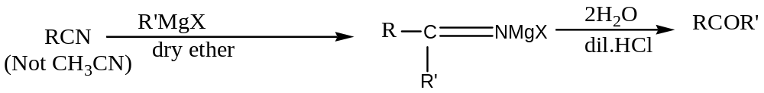
For Carboxylic Acid
Example
Write equations showing how Benzoic acid can be prepared from Bromobenzene 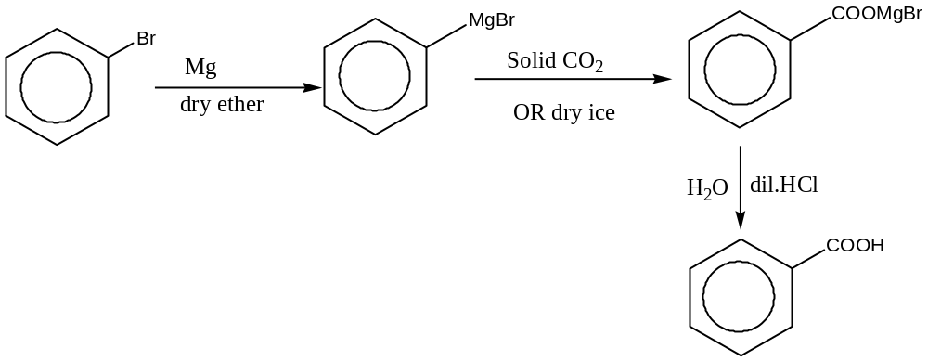
7. Alcohol Formation
On heating, Alkyl halides react with sodium hydroxide solution on heating to form an alcohol.
For 3º Alkyl halide, the kinetic studies show that it is First order with respect to the alkyl halides consequently the rate determining step involves only the haloalkane therefore the mechanism and reaction is known as Substitution Nucleophilicunimolecular (S_{N}1)
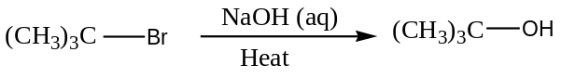
Mechanism
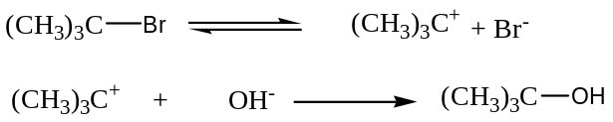
Qn: Draw a well labelled energy profile diagram for the reaction and State rate law for the reaction above.
For 1ºhaloalkane alkaline hydrolysis, the kinetic studies show that it is second order reaction therefore the dependent on the concentration of Haloalkane and hydroxide ions.
Consequently the rate determining step involves both species therefore the mechanism and reaction is known as Substitution Nucleophilic bimolecular (S_{N}2)
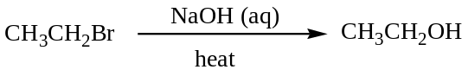
Mechanism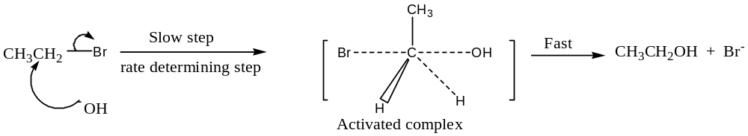Qn: Draw a well labelled energy profile diagram for the reaction and State rate law for the reaction above.
Secondary haloalkanes show a mixture of both second and first order kinetics with the former predominating.
8. Alkene Formation or Elimination reaction
The reaction involves removal of halide ion and hydrogen to form the alkene. The hydrogen atom removed is the one bonded to the carbon atom adjacent to the one bonded to the halogen.
Unimolecular elimination (E₁)
This is undergone by 3ºhaloalkane to generate an alkene in presence of alcoholic potassium hydroxide and heat.
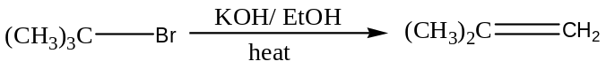
Qn: Write the mechanism for the reaction
Bimolecular Elimination (E₂). This is undergone by 1ºhaloalkane and in the rate determining involves both the haloalkane and base to generate the alkene.
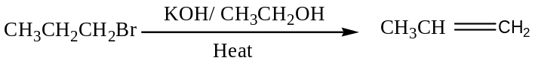
Qn: Write the mechanism for the reaction.
9. Reduction reaction
This can be done by:
(a) Using Lithium Aluminium hydride in dry ether.
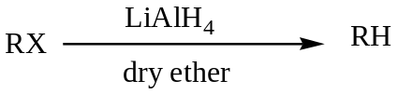
(b)Using sodium metal in dry ether (Wurtz reaction)
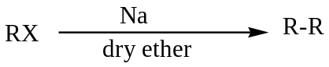
ELECTROPHILIC SUBSTITUTION REACTION OF ARYL HALIDES
Aryl halides differ in reaction from haloalkanes in that they do not undergo substitution of the halogen. This is because the lone pair of electrons on the halogen atom interacts with the delocalized electrons of the benzene ring. This strengthens the carbon-halogen bond or makes the carbon-halogen partly double bonded and difficult to break.
In the Alkyl halides, the carbon-halogen bond is polar because the halogen is a more electronegative atom therefore the carbon atom becomes partial positively charged atom. It is then attacked by electron rich species (Nucleophile) leading to substitution of the halogen atom.
Generally Aryl halides undergo Electrophilic substitution reaction to generate ortho and Para products.
Some of the reactions include:
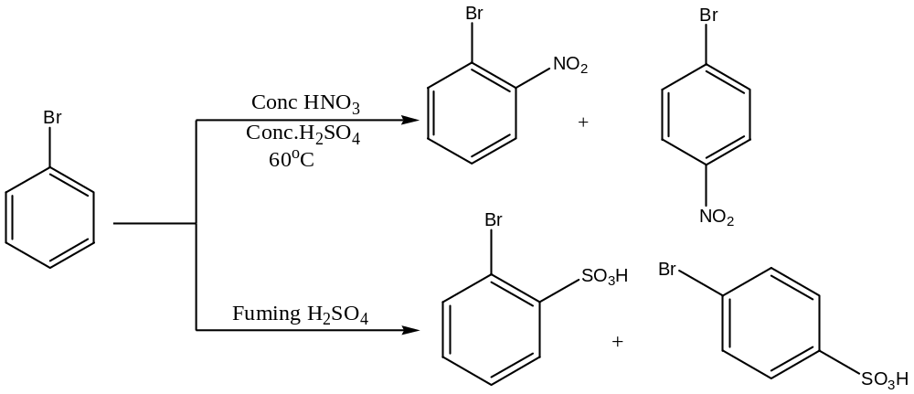
Reagents used to distinguish Aryl halides from Alkyl halides include:
Hot silver ethanoate in ethanol or hot sodium hydroxide solution and silver nitrate solution
Sample Question:
1. Suggest Explanations for each of the following observations:
- Iodobenzene is more reactive than chlorobenzene towards but much less reactive than iodoethane.
- Tetrachloromethane is much less reactive towards Nucleophiles than chloromethane
- Iodo-and Bromo-compounds are much more useful as intermediates in synthesis than chloro-compounds.
2. Using equations indicating the required conditions to show how the following compounds can be synthesized:
3. (a) Methyl Benzene reacts with chlorine to form Chloromethylbenzene. State the conditions for the reaction
(b) Under different conditions the product is phenyl chloromethane instead of Chloromethylbenzene.
(i) State these conditions of the reaction (ii) Write a plausible mechanism for the reaction.
CHAPTER SEVEN

ALCOHOLS OR ALKANOLS AND PHENOL
Introduction
Aliphatic Monohydric Alcohols are monohydroxyl derivatives of alkanes and have a general formula C_{n}H_{2n+1}OH or C_{n} H_{2n+2}O
Aliphatic monools may be classified as 1º,2º or 3º according to the nature of the carbon atom to which the hydroxyl group is attached i.e.
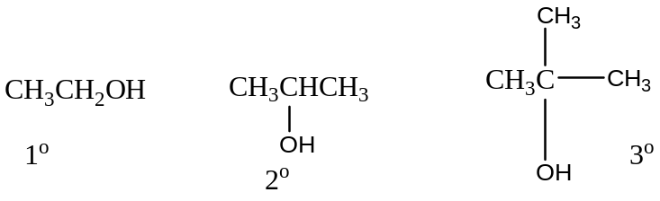
Aromatic Alcohols have aryl group attached to aliphatic portion of the alcohol separated by at least a methylene group. E.g
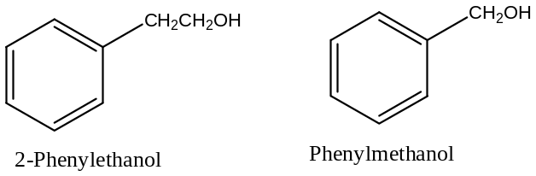
Compounds in which the hydroxyl group is attached directly to the benzene (Aromatic)ring are classified as Phenol. E.g
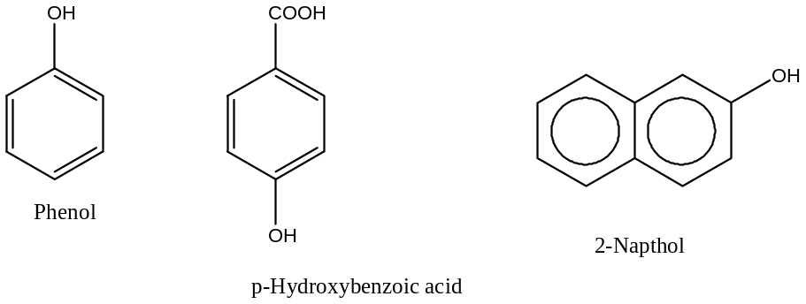
Alcohols containing two hydroxyl groups are described as dihydric alcohols or diols and those with three hydroxyl groups are triols while those containing many hydroxyl groups are polyols. E.g.
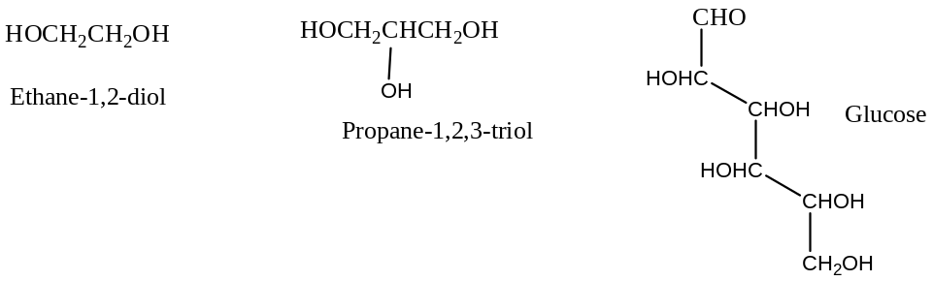
NOMENCLATURE OF ALCOHOLS
The IUPAC Names are obtained by dropping the ending “–e “of alkane and replacing it with suffix “-ol”. The position of the hydroxyl group is indicated by inserting an appropriate number between the stem name and ol.
Example:
Name the following compounds using the IUPAC System
(a)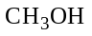 (b) 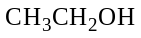 (c)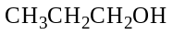 (d) 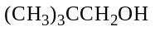
(e)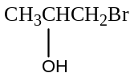 (f) 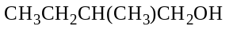 (g) 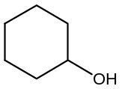 (h) 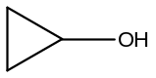

Solution
(a) Methanol (b) Ethanol (c) Propan-1-ol (d) 2,2-dimethylpropan-1-ol
(e) 1-bromopropan-2-ol (f) 2-methylbutan-1-ol (g) Cyclohexanol (h) Cyclopropanol
ISOMERISM
Aliphatic monools have structural isomers .i.e. Chain, functional and Positional Isomers.
Ethers are functional isomers of monools.
Example:
A compound X has molecular formula C₃H₈O. Write down the structural formulae and names of the possible isomers of X.
Solution:
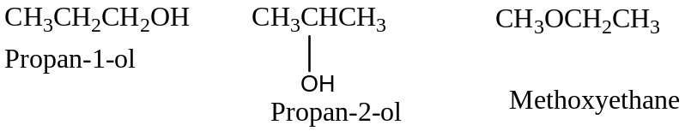
SYNTHETIC PREPARATION OF ALCOHOLS
- From Alkenes
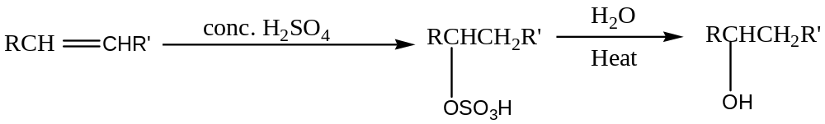
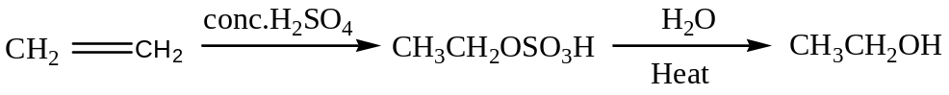
- From Alkyl halides
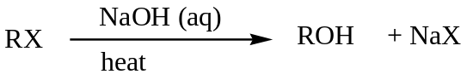
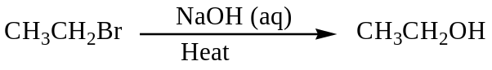
- From Carbonyl compounds
Reduction of carbonyl compounds generates alcohol. Aldehydes are reduced to Primary Alcohol while Ketones to Secondary Alcohol.
The reducing agents commonly used are Na/ethanol, LiAlH₄ in dry ether, NaBH₄ and water, amalgamated Zinc and concentrated Hydrochloric acid, finely divided Ni or Pt with hydrogen gas.
Lithium Aluminium hydride does reduce a double bond if it is present in the carbonyl compound.
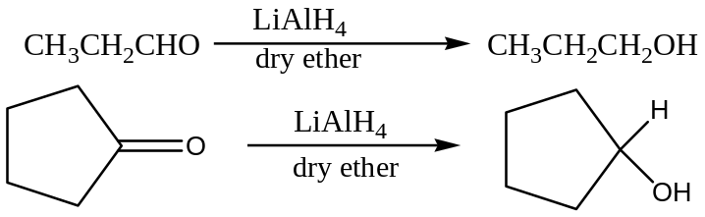
- Grignard Reagent Synthesis
See Reactions of Haloalkanes.
- Reduction Of Carboxylic acids
Carboxylic acids are reduced to Primary Alcohols using LiAlH₄ in dry ether.
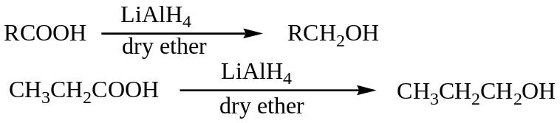
- From Esters
Esters are hydrolysed by aqueous sodium hydroxide solution to generate an alcohol. However this is not usually done since esters are obtained from alcohols.
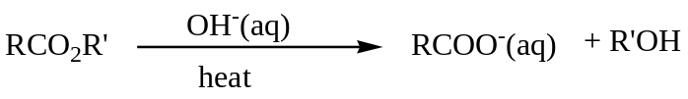
- Cannizzaro Reaction
Aromatic Aldehydes without -hydrogen atoms undergo self-reduction and oxidation in sodium hydroxide solution.
DOMESTIC PRODUCTION OF ETHANOL
Ethanol is mainly prepared by fermentation process. Fermentation is a process where starch or sugar is converted to ethanol by yeast enzymes.
The main sources of the starch materials include maize, millet, cassava, sorghum, potatoes, banana, rice, molasses, etc.
The enzymes that participate in the fermentation process and their stages include:
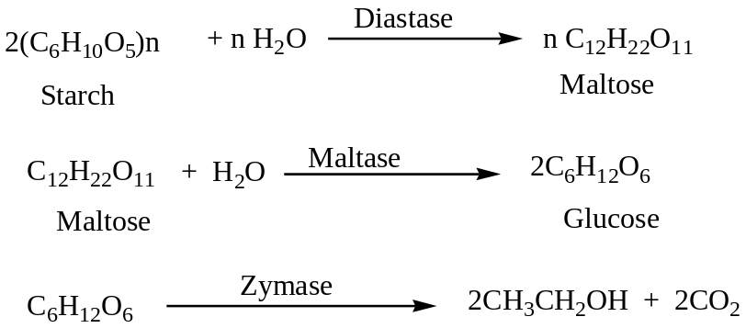
Qn:
- Describe the processes involved in the production of ethanol from a named material domestically
- State briefly how the purification of the ethanol produced can be done
- State four uses of ethanol
- State two effects of over consumption of ethanol on the human body.
Physical Properties of Alcohols
- Solubility
Lower members of the series are soluble however, solubility decreases as the hydrocarbon portion increases. The miscibility of alcohols is due to ability of the formation of hydrogen bond with water molecule.
- Boiling Points
Alcohols boil at higher temperatures expected because the molecules associate through hydrogen bonding which requires an extra energy to break.
Within the series, boiling points increase with molecular mass.
- Density
Density increases with increasing molecular mass although branching reduces the factor. Aliphatic alcohols are less dense than water while Aromatic alcohols tend to be slightly denser than water.
REACTIONS OF ALCOHOLS
- With Electropositive Metals
Although Alcohols are neutral to neutralization indicators, the hydroxyl group can be replaced by metals of Group I and II of the periodic table. The products are hydrogen gas and metal Alkoxide.
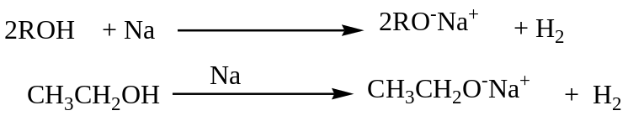
- Halogenation
This can be done by:
- Using Hydrogen Halide
They react with hydrogen halides to form alkyl halides. The order of reactivity for alcohols is 3º>2º>1º while for hydrogen halides is HI>HBr>HCl.
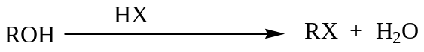
1º Alcohols undergo bromination with hydrogen bromide which is generated from sodium bromide and concentrated sulphuric acid.
In case of hydrogen chloride, the reaction is carried by using anhydrous Zinc chloride and concentrated hydrochloric acid. (Luca’s Reagent)
The reagent is used to distinguish the classes of monools i.e.
- 3⁰ Alcohol forms a cloudy solution immediately
- 2ºAlcohols forms cloudiness between 5-10minutes
- 1º Alcohol no observable change.
Mechanism
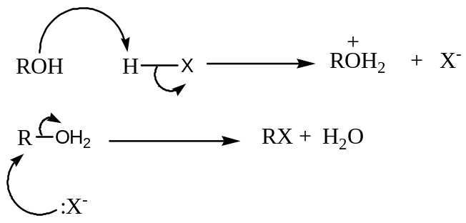

- Using Phosphorous Halides
- Using Thionyl chloride
Thionyl Chloride and Phosphorous pentachloride generate alkyl chloride.
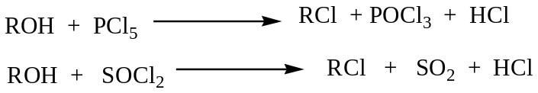
- Concentrated Sulphuric acid
The products of the reaction depend on the conditions of the reaction under which it is carried out.
- At lower temperatures (below 140ºC), alkyl hydrogen sulphate is obtained
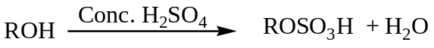
(ethyl hydrogen sulphate)
Mechanism
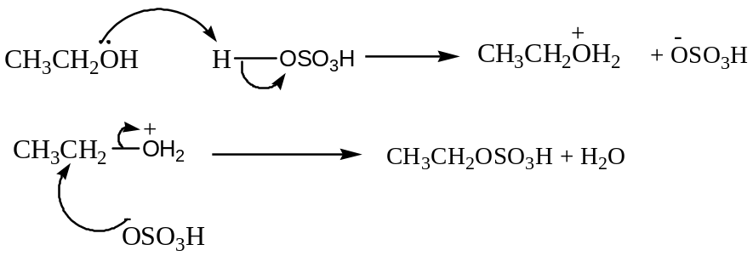
- At about 140ºC when excess alcohol, ether is obtained.
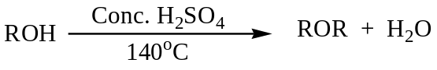
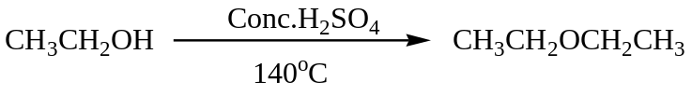
Mechanism
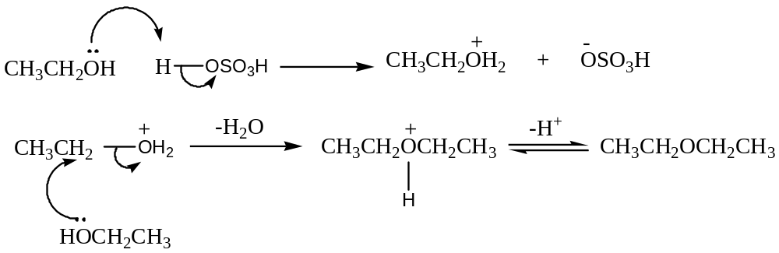
- When the reaction is carried out at about 180ºC, an alkene is obtained. Aluminium Oxide at 350ºC or concentrated orthophosphoric acid can be used.
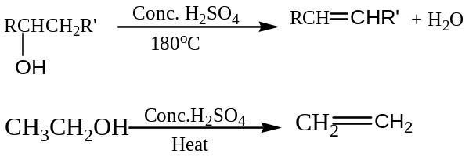
- Oxidation reaction
The product oxidation depends on the type of alcohol and partly the power of oxidizing agent.
Primary Alcohols are oxidized to Aldehydes and the reaction proceeds to carboxylic acid while Secondary Alcohols are oxidized to Ketones.
Tertiary Alcohols are resistant to oxidation.
The oxidizing agents commonly used are acidified potassium dichromate or acidified chromium (VI) oxide
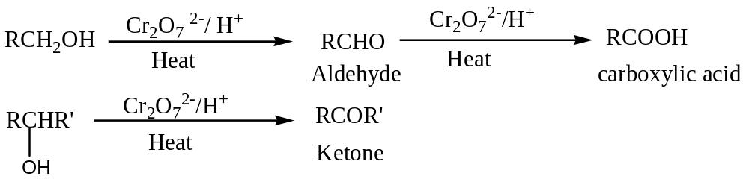
- Esterification reaction
The process whereby a primary alcohol reacts with a monocarboxylic acid is known as esterification.
The reaction usually takes place in presence of concentrated sulphuric acid and it is reversible reaction.
Example:
Mechanism:
This was determined using radioactive Oxygen (18). The primary alcohol containing oxygen-18 is reacted with monocarboxylic acid. The mass spectrometer is used to analyse the ester and water formed. The oxygen-18 is found in the ester only and not water indicating that carbon-oxygen single bond in the acid and oxygen-hydrogen bond in the alcohol are bonded.
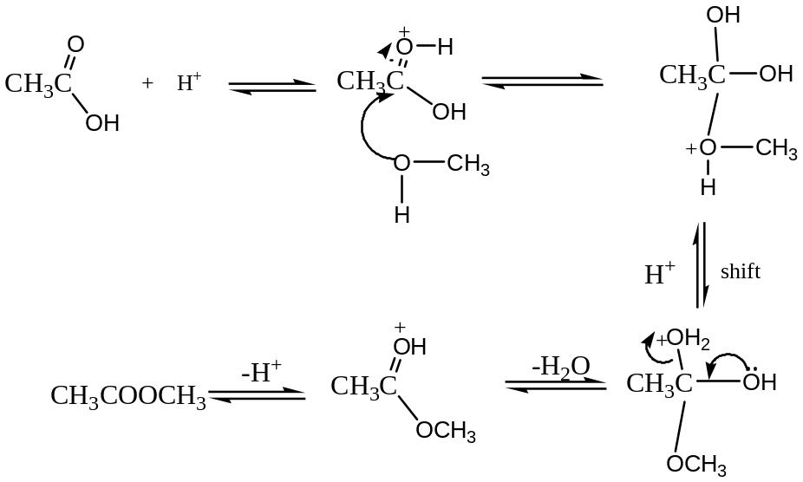
- Iodoform reaction
Alcohols of the form 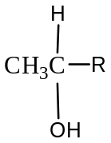react with iodine in presence of sodium hydroxide solution to form a yellow solid.
Iodine is an oxidizing agent and can oxidize alcohols to Aldehydes or Ketones.
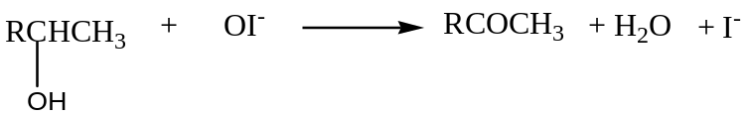
OR
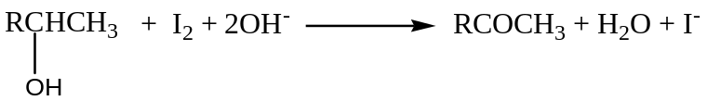
Ethanol is the only primary alcohol which gives a positive.
N.B. Chlorine forms chloroform which is colourless liquid, Bromine forms bromoform which is reddish-brown.
PHENOL
Introduction
These are compounds containing a hydroxyl group attached directly to aromatic nucleus (Benzene) and have a general formula ArOH.
Like alcohols they may be monools or polyols depending on the number of the hydroxyl groups they contain.
Examples include:
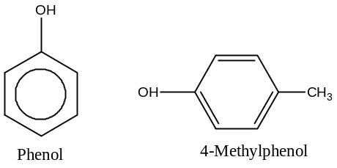
Physical Properties
Phenol is colourless crystalline solid although often found red tint due to presence of oxidation products. It is slightly soluble but very soluble in organic solvents.
N.B. The introduction of the hydroxyl group into an already substituted aromatic ring especially in position-4 produces a marked increase in the boiling point. E.g. the greater volatility of 2-nitrophenol is attributed to intramolecular hydrogen bonding while the higher boiling points of 3- and 4- isomers are direct result of intermolecular hydrogen bonding.
Preparation of Phenol
- From Benzene sulphonic acid
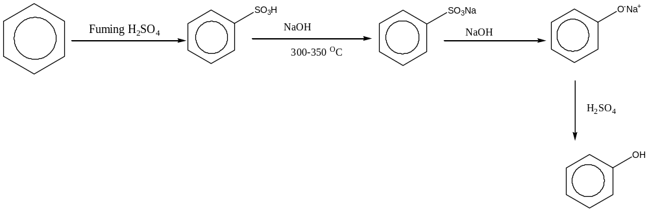
- From Benzene Diazonium salt.
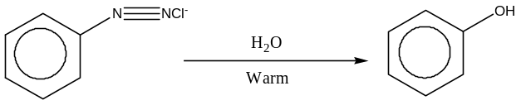
- Cumene process
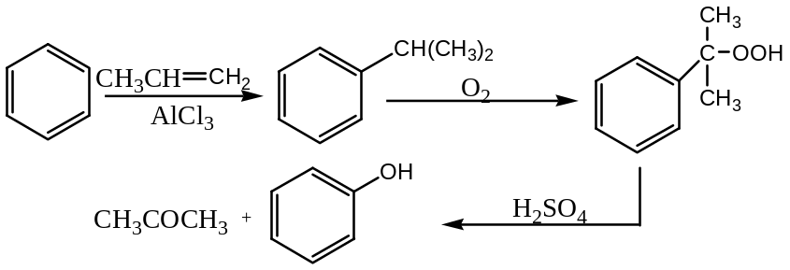
Reactions of Phenol
Phenol undergoes two distinct reactions i.e.
- Side-chain substitution reactions which generally involves replacement of the acidic proton
- Electrophilic substitution in the ring.
Phenol as an acid
Phenol is a stronger acid than alcohols but weaker acid compared to carboxylic acid.
Qn: Explain briefly why phenol is more acidic compared to Ethanol
Soln: In phenol, the lone pair of electrons on the oxygen atom interacts with delocalized electrons of the benzene ring. This strengthens the carbon-hydrogen bond while weakening the oxygen-hydrogen bond consequently; phenol loses a proton easily making it acidic.
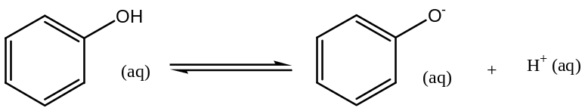
In ethanol, the oxygen-hydrogen bond is not weakened and the proton is not easily lost. This is because there are no delocalized electrons to interact with lone pairs of electrons on the electrons.
Note: Due to the above reason, phenol differs from alcohols in that it does not react with halogen acids or Phosphorus halides and does not undergo elimination reaction
- Side-chain reactions include:
- Esterification reaction
Phenol reacts with acid chlorides and acid anhydrides to form esters
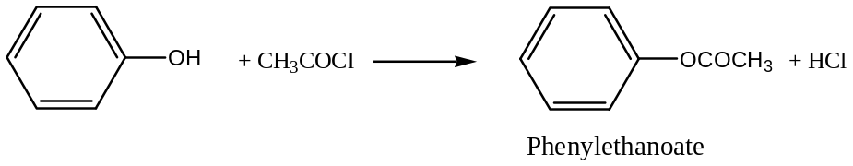
- Ether Formation
Sodium phenate (Sodium phenoxide) reacts with alkyl halides to form ethers
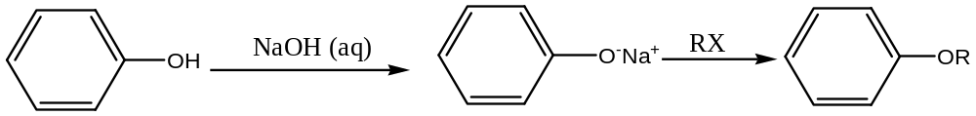
- With Neutral Iron (III)chloride solution
Phenol reacts with neutral Iron (III) chloride solution to form a violet colouration due to a complex formed.
- Electrophilic Substitution of the ring
Phenol is more reactive towards Electrophilic reagent than Benzene since it activates position 2- and 4- therefore the products formed at those positions.
- Reduction reaction
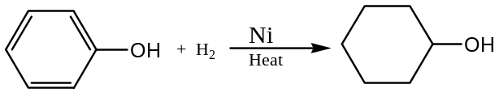
- Nitration reaction
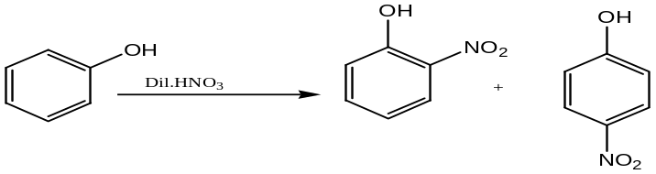
- Bromination
In aqueous solution, phenol reacts with bromine to form a white precipitate of 2, 4, 6-tribromophenol.
This reaction is used also to test for presence of phenol and estimate phenol quantitatively.
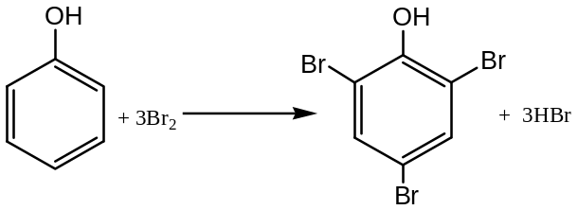
- Coupling with Benzene Diazonium salts
Benzene Diazonium salt solution is added to alkaline solution of phenol to generate bright yellow precipitate of 4-hydroxyphenylazobenzene.
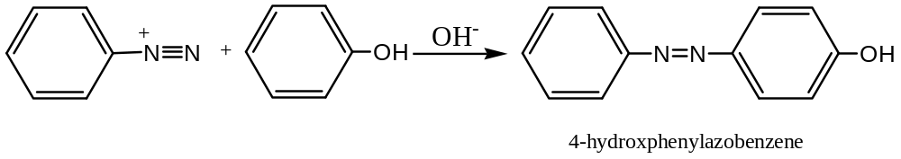
Question
- Explain the following observation:
- Ethanol is more acidic than 2-methylpropan-2-ol but less acidic than phenol
- Phenol is easily nitrated using nitric acid whereas Benzene is nitrated using a mixture of concentrated nitric acid and sulphuric acid
- Butan-1-ol is more soluble in 5M hydrochloric acid than in water
- The boiling point of ethanol (78ºC) is greater than Ethoxyethane (35ºC)
- Write the half and overall equation of reaction for:
- Ethanol and acidified potassium dichromate solution
- Ethene and acidified potassium manganate (VII) solution

CHAPTER EIGHT
CARBONYL COMPOUNDS
Introduction
Aldehydes and Ketones are referred to as Carbonyl compounds as both contain the carbonyl functional group.
The saturated aliphatic series are homologous and correspond to a general molecular formula C_{n}H_{2n}O.
Aldehydes possess single hydrogen attached to the carbonyl carbon whereas Ketones always contain two hydrocarbon groups
Aldehydes are more reactive therefore easily oxidized and also more susceptible to Nucleophilic addition.
Nomenclature of Aldehydes and Ketones
For Aldehydes, the IUPAC names are obtained by dropping the ending “-e”of the corresponding alkane and replacing it with suffix “-al” for Aldehydes name.
The IUPAC names for Ketones is also obtained by dropping the ending”-e” of alkanes and replacing it with suffix”-one”
The position for carbonyl group is indicated by inserting an appropriate number between stem name and –one.
Example
Name the following organic compounds:
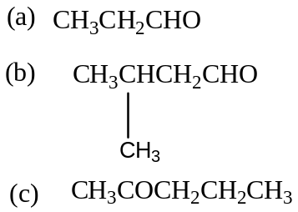

PHYSICAL PROPERTIES OF CARBONYL COMPOUNDS
Simple aliphatic Aldehydes and Ketones with exception of methanal are all colourless liquids. The lower Aldehydes possess rather unpleasant smell whereas Ketones and Benzenecarbaldehyde have pleasant, sweet odours.
Methanal is a gas at room temperature and rest are liquids. Carbonyl group is polar therefore Aldehydes and Ketones have a higher boiling points but lower than those of alcohols since they do not form strong hydrogen bonds with each other.
Lower Aldehydes and Ketones are appreciably soluble in water due to their ability to form hydrogen bonds with water molecules and the resultant solution is neutral to litmus.
The density of the aliphatic compounds of both series is less than that of water but it increases with increase in molecular mass.
Synthetic Preparations
- Oxidation of Alcohols
1º Alcohols are oxidized to Aldehydes while 2º Alcohols are oxidized to Ketones using acidified potassium dichromate or acidified chromium (VI) oxide.
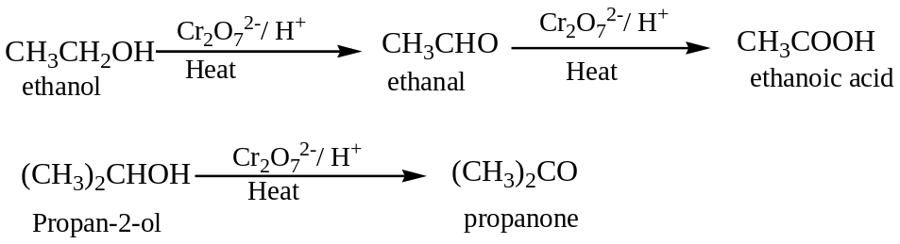
Oxidization can also be accomplished by dehydrogenation of the alcohol using copper catalyst heated at about 300ºC
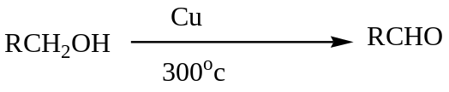
- From Grignard reagent.
When Grignard reagent reacts with cyanide compounds and on hydrolysis a Ketones are obtained.
- Decarboxylation method of Calcium salts
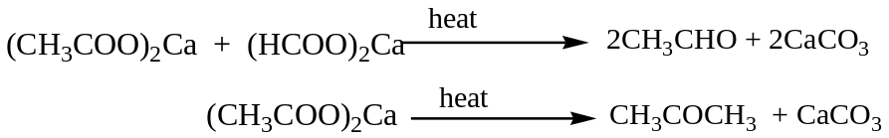
- Ozonolysis of Alkenes
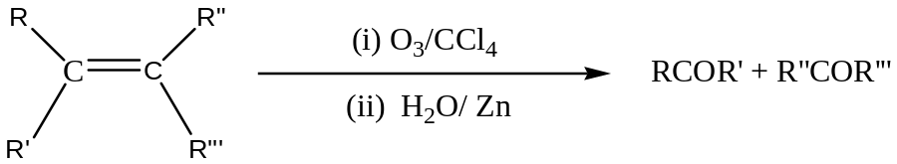
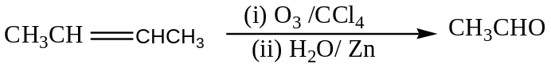
- Hydration of Alkynes
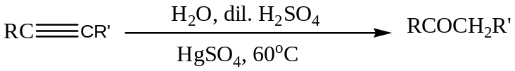
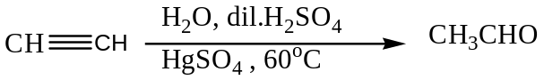
- From methyl benzene
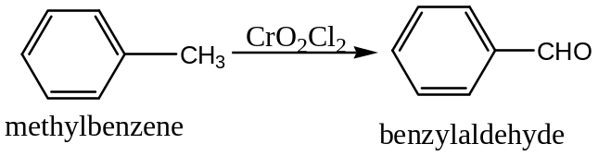
QN: Show methyl benzene can be converted to Benzoic acid using equation (s) of reactions.
- Acylation method
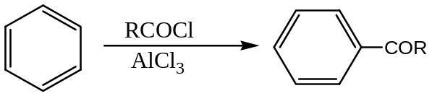
Question:
- Write the mechanism of the reaction above
- Using equations show how 1-phenyl ethanol can be prepared from benzene.
- Write equations showing how Benzene can be obtained from 1-phenylethanol.
Reactions of Carbonyl compounds
In carbonyl compounds, the carbonyl carbon has a partial positive charge because it is bonded to a more electronegative oxygen atom therefore it is attacked by a Nucleophile.
The susceptibility of the carbonyl carbon to Nucleophilic attack is reduced by its attachment to electron-releasing alkyl or aryl groups which reduces the degree of positive charge on the carbon.
Steric hindrance by the hydrocarbon groups impedes the approach of the attacking Nucleophile and reduces the reactivity.
Some of the Nucleophilic addition reactions include;
- Addition of Hydrogen cyanide:
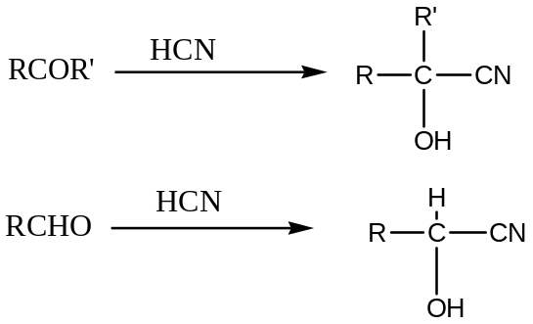
Hydrogen cyanide is usually prepared during a reaction of dilute sulphuric acid on alkali metal cyanide.
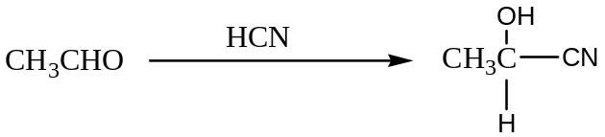
Mechanism
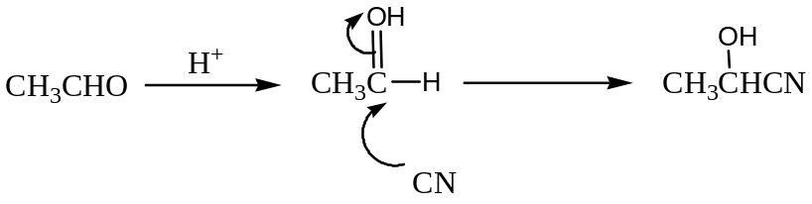
Cyanohydrins are used to synthesize 2-or-hydroxy acids on hydrolysis.
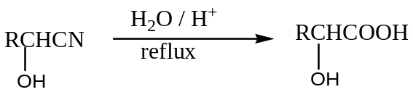
Qn: Using equations indicating the necessary conditions show Ethene can be converted to 2-hydroxypropanoic acid.
- Addition of saturated sodium hydrogen sulphite solution
The reaction occurs readily with most Aldehydes and some Ketones especially methyl Ketones to form white solids of Aldehydes or Ketones hydrogen sulphite.
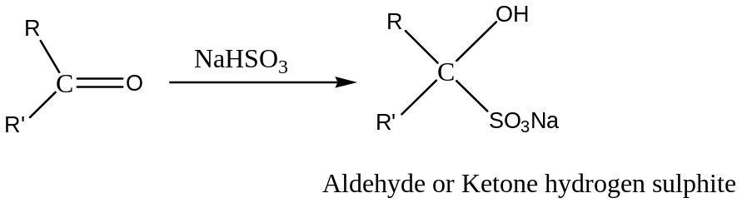
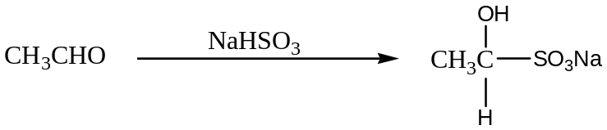
Mechanism
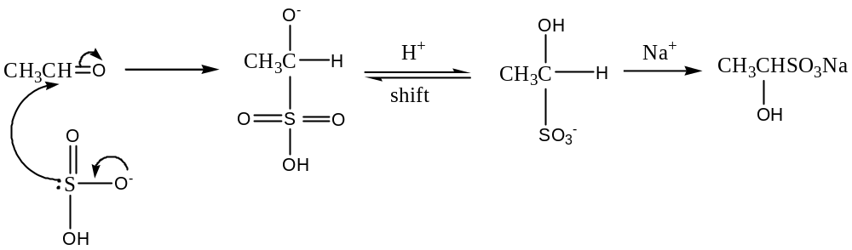
Qn: Write equation showing show Propanone can be converted to Propanone hydrogen sulphite and indicate the mechanism of the reaction.
- Condensation reaction or Elimination of water molecules.
In this reaction, carbonyl compounds react with derivatives of ammonia of general form X-NH2 to release water molecules.
The final products are usually solids which are easily isolated and purified by recrystallisation.
Some of the addition reagents include:
- With Hydroxylamine,NH₂OH
The product formed is white solid is Aldehydes or Ketone oxime.
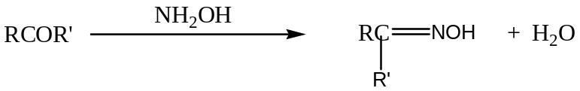
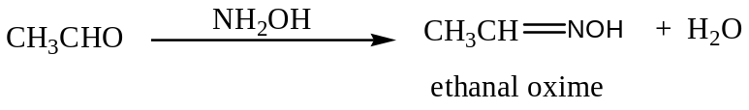
Qn: Write the mechanism of the reaction above and show how the product formed can be converted to:
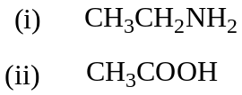
- With hydrazine, NH₂NH₂
The product is Aldehydes or Ketoneshydrazone which in excess yield azine.
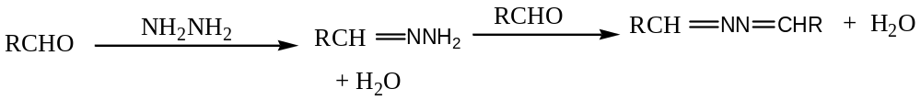
Mechanism
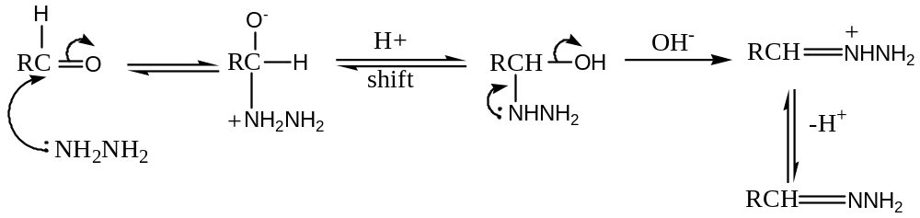
N.B. In presence of an acid, protonation is the first stage
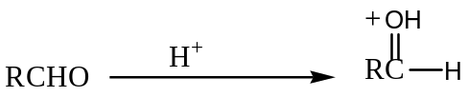
- With Phenyl hydrazine C₆H₅NHNH₂
Carbonyl compounds generate phenyl hydrazone derivatives which are low melting point solids. The reaction occurs with or without an acid.
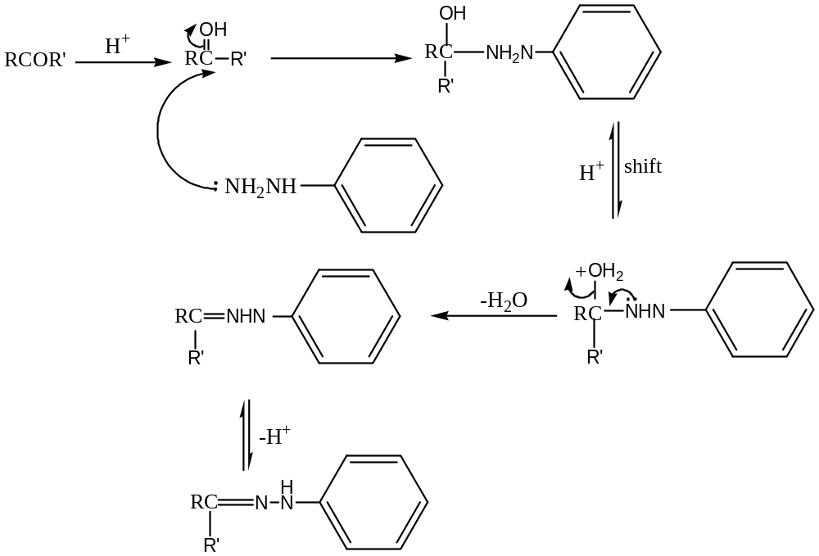
- With 2,4-dinitrophenylhydrazine
2,4-dinitrophenylhydrazine is utilized in Brady’s reagent for detection of a carbonyl functional group. Yellow or orange solid crystallizes out in the form of 2,4-dinitrophenylhydrazone.
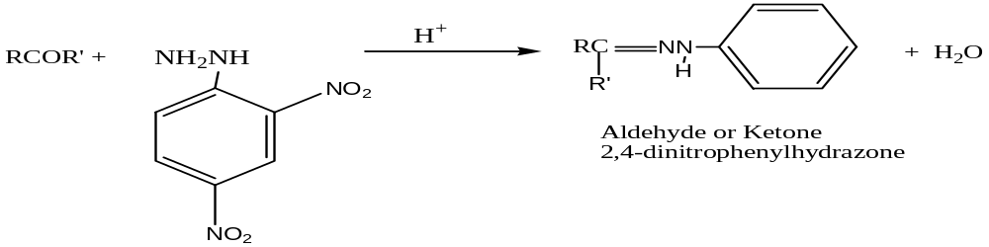

- With semicarbazide, NH₂NHCONH₂
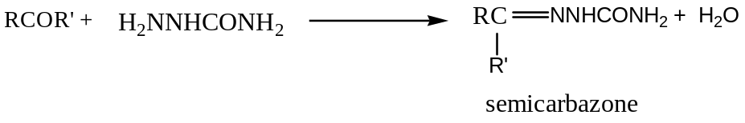
- Reaction with Primary amines.
Aldehydes react with primary amines to form imines.
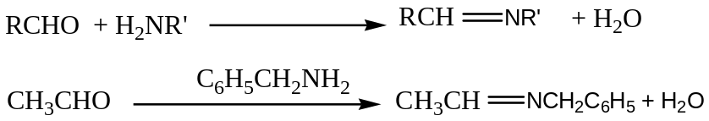
- Aldol condensation
Aldehydes react with alkali to generate Aldol product which dimerises on warming to enal.
The reaction is undergone by carbonyl compounds with at least one-α-hydrogen atom.
- Cannizzaro reaction
Aldehydes without at least one-α-hydrogen atom react with sodium hydroxide solution to undergo self-oxidation and reduction reaction.
This reaction is limited to aromatic and aliphatic compounds in which the carbonyl carbon is attached to tertiary alkyl carbon atom.
- Oxidation reaction
Aldehydes are oxidized to carboxylic acids by oxidising agents such as acidified potassium dichromate solution, acidified chromium (VI) oxide solution or dilute nitric acid.
Ketones are resistant to oxidation by common oxidising agents.
- Reduction reaction
Aldehydes are reduced to Primary alcohol while Ketones are reduced to Secondary Alcohol.
Reducing agents commonly used are LiAlH₄/ dry ether, Hydrogen /Nickel at 150^{O}C, Amalgamated Zinc and concentrated hydrochloric acid, NaBH₄/ Water.
- Halo form reaction
Ethanal and Methyl Ketones react with iodine in presence of sodium hydroxide solution to form a yellow solid.
This reagent is used to differentiate between the structure of Aldehydes and methyl Ketones.
- Addition of Grignard reagent
Aldehydes generate Secondary Alcohol except methanal while Ketones generate tertiary alcohol.
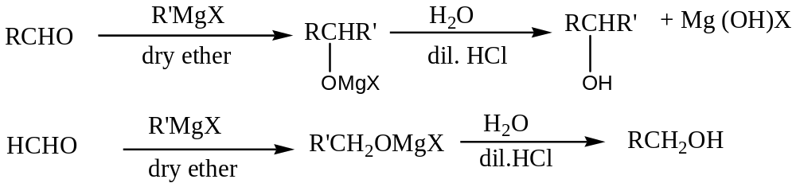
- With Phosphorous penta chloride
Carbonyl compounds generate dichloride.
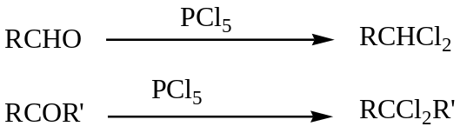
Distinguishing between Aldehydes and Ketones
Aldehydes can be differentiated from Ketones by various reagents that are oxidizing agent’s i.e.
- Ammoniacal Silver nitrate solution.
The reagent consists of silver nitrate in presence of excess ammonia solution.
Aldehydes react with ammoniacal silver nitrate form a silver mirror along side a clean test tube on warming whereas no observable change for Ketones.
Ethanal reacts almost immediately.
- Fehling’s test.
Aliphatic Aldehydes reduce copper (II) ions to reddish-brown copper (I) oxide on heating.
Ketones and aromatic Aldehydes give no observable change.
Reactions of Aromatic Aldehydes and Ketones involving substitution in Ring
Carbonyl group is deactivating group therefore the reaction involving the benzene ring generate meta-derivative product.
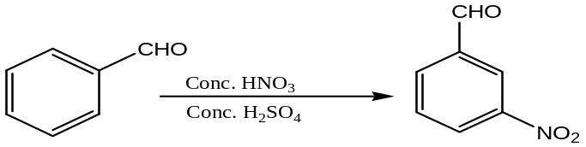

CHAPTER NINE
CARBOXYLIC ACIDS
Introduction
Aliphatic monocarboxylic acids form a homologous series corresponding to the general molecular formula, C_{n}H_{2n+1}COOH.
Carboxylic acids are organic compounds contain the carboxyl group that is made of carbonyl group and hydroxyl group.
The number of the carboxyl group present in acid classifies acids as: Monocarboxylic acids which are monobasic have one carboxyl while dicarboxylic acid are dibasic.
The simplest dicarboxylic acid are:
Nomenclature
The IUPAC names are afforded by taking the name of the appropriate alkane and replacing the ending –“e” with the suffix “oic acid”. Positions of the substitution are denoted in the usual way by numbering the longest unbranched chain containing the carboxyl group.
Synthetic Preparations
- Oxidation of Primary Alcohol or Aldehydes
Primary Alcohols or Aldehydes are oxidized by acidified potassium dichromate solution or acidified chromium (VI) oxide to carboxylic acid.
Orange solution turns green due to reduction of chromium (VI) ions to chromium (III) ions.
- Grignard synthesis
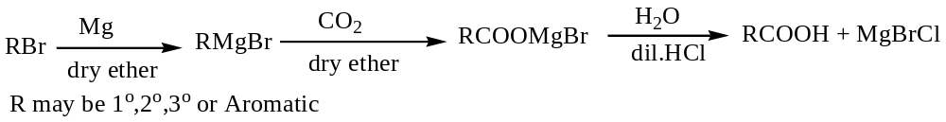Example
In Preparation of Benzoic acid, solid carbondioxide or dry ice is used.
- From Methyl Benzene
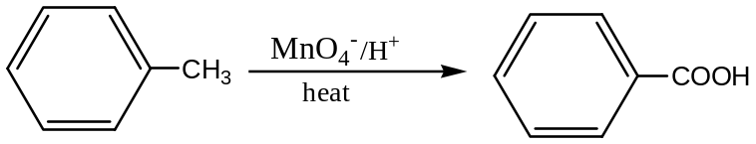
- From Cyanide compounds.
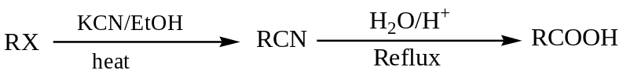
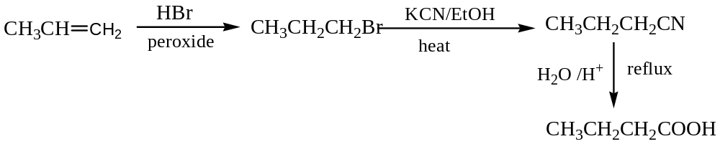
The reaction is unsuitable for preparation of aromatic carboxylic acid.
- Cannizzaro reaction
Aromatic Aldehydes and aliphatic ones containing no α-hydrogen atom undergo self-oxidation and reduction.
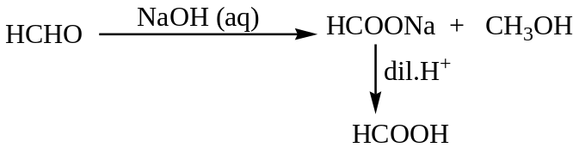
- Alkali Hydrolysis of Esters
The hydrolysis of Esters generates the corresponding alcohol and Acid.
The method is not commonly used since esters are obtained from carboxylic acid.
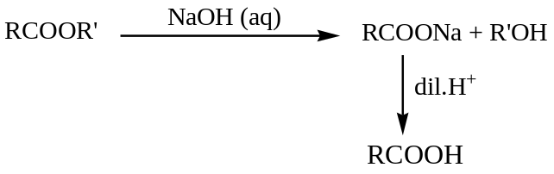
Physical Properties of Carboxylic acids
All simple aliphatic acids as far as C₁₀ are liquids at room temperature while aromatic acids are crystalline solids. Ethanoic acid has a sharp, pungent odour.
Boiling points of the acids increase with increase molecular mass. The boiling points are higher than expected because of the ability of the molecule to associate through hydrogen bonding which requires extra energy to break.
The first four aliphatic acids are completely miscible with water due to the ability of the functional group to form hydrogen bonds with water molecules.
Because of their greater hydrocarbon hence covalent character, the higher homologues become progressively less soluble in water.
Benzoic acid is only slightly soluble in cold water but dissolves readily in hot.
N.B. The molecular mass determination of carboxylic acids using Colligative properties such as freezing point in non-polar solvents gives the results that are twice than expected due dimerisation of the molecule through hydrogen bonding in such solvents.
Acidic nature of carboxylic acids
Carboxylic acids are weak acids which partially dissociate in aqueous solutions. However, they are stronger acids than alcohols and phenols.
The acidic strength of carboxylic acids depend on degree of ionisation and the acid dissociation constant denoted K_{a} defined as
K_{a} = 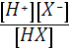for a weak monobasic HX acid.
The Nature of the groups close to the carboxyl group has a great effect on the acid strength therefore a phenomenon known as inductive effect.
Electron withdrawing groups’ e.g halogens makes carboxylic acid stronger thus oxygen-hydrogen bond becomes weaken hence release of hydrogen ions in aqueous solution. i.e.
Electron releasing groups’e.g alkyl groups makes carboxylic acid weaker thus oxygen-hydrogen bond strengthen hence less amount of hydrogen ions in aqueous solution.

Reactions of carboxylic acids
The reactions of carboxylic acids involve the hydroxyl group which either undergoes the loss of proton or replaced by another atom or group.
Some of the reactions include:
- With Bases
The react to form salts and water
- With electropositive metals.
The react to form salts and hydrogen
- With sodium carbonate or Sodium hydrogen carbonate
They react to liberate carbondioxide gas. They are stronger acids than carbonic acid.
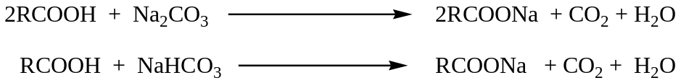
- With Primary Alcohols
Carboxylic acids react with primary alcohols in presence of concentrated sulphuric acid as catalyst to form esters.
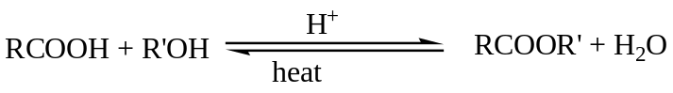
(See Alcohols for mechanism of the reaction)
- With Phosphorous Halides
They react to acid chlorides.
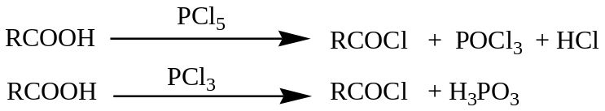
- With Thionyl chloride
They react also to form acid chlorides. This is the convenient method for preparation of acid chlorides since the other two products are gaseous.
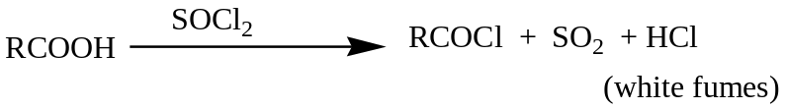
- With Iron (III) chloride solution
They react forming a reddish-brown precipitate or solution. Lower molecular mass acids form a solution.
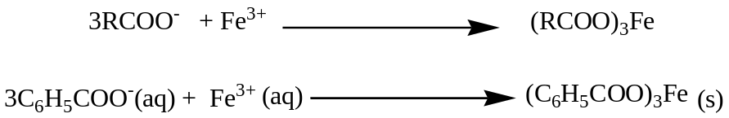
- Reduction reaction
Carboxylic acids are reduced to primary alcohols using lithium aluminium hydride.
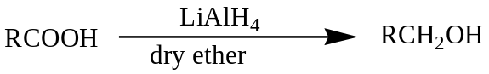
- Reaction of the Alkyl group
When chlorine gas is bubbled through hot carboxylic acid in presence of ultraviolet light, one or all the hydrogen atoms adjacent are substituted.
- Decarboxylation reaction.
This reaction decreases the carbon length of the sodium salt of carboxylic acid to form an alkane.
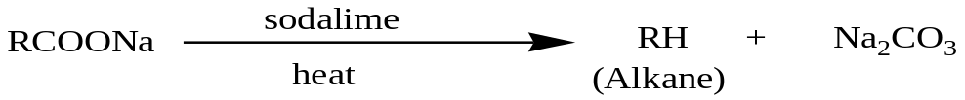

- Amide formation.
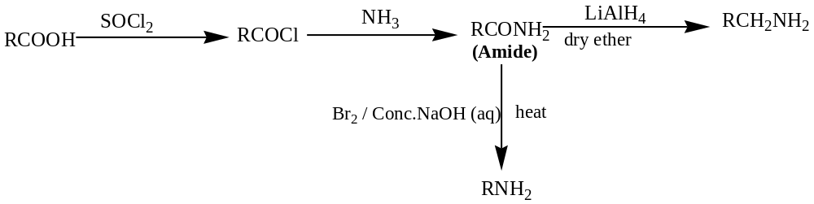
- With Ammoniacal Silver nitrate solution
Methanoic acid is the only carboxylic acid that reacts with ammoniacal silver nitrate solution on warming due to presence of Aldehydes group to form silver mirror along side a clean test tube.
- Dehydration reaction
Methanoic acid and Ethanedioic acid are the only carboxylic acid that can be dehydrated using concentrated sulphuric acid.
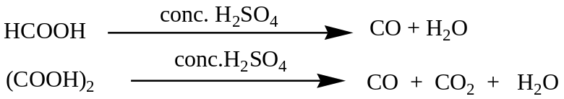
Question
- How would one carry out the following conversions in the laboratory? Indicate the necessary conditions of the reaction.
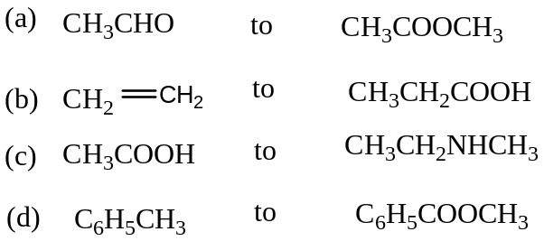
- Three isomeric acids A, B and C have molecular formula C₈H₆O₄ and all contain a benzene ring. In each case, one mole of the acid will react with 2moles of sodium hydroxide. Suggest structures for the acids. When the three acids are separately heated, A and B melt without decomposing, but C loses a molecule of water at about 250ºC to form D,C₈H₄O₃.Suggest structures of C and D
- Explain the following observations:
- When dilute hydrochloric acid is added to aqueous solution of soap, a white insoluble substance is formed.
- Butane, Propan-1-ol, Propanal and Ethanoic acid have approximately the same molecular mass yet their boiling points are 273, 370 and 391K respectively.
- Methanoic acid reacts with ammoniacal silver nitrate solution while Ethanoic acid does not.
- Ethanedioic acid decolorizes potassium manganate (VII) solution on warming while Ethanoic acid does not.
READ ON THE FOLLOWING ASPECTS
DERIVATIVES OF CARBOXYLIC ACIDS
- AMIDES
- ACID CHLORIDES
- ACID ANHYDRIDES AND ESTERS

CHAPTER TEN
AMINES
Introduction
Amines are alkyl or aryl derivatives of ammonia, and may be classified as Primary, secondary and tertiary according to the number of alkyl or aryl groups attached to the nitrogen atom.
Aromatic amines are amines in which the nitrogen atom is attached directly to the aromatic ring.
Compounds containing two amine groups are known as diamines.
Examples of amines are their classes include 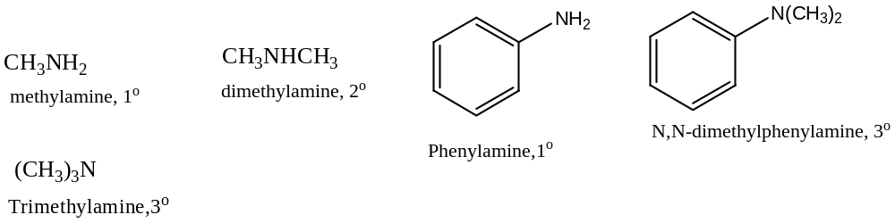
Nomenclature
Both aliphatic and aromatic amines can be named by inserting the ending “amine” to the name of alkane or other appropriate hydrocarbon.
Examples include:
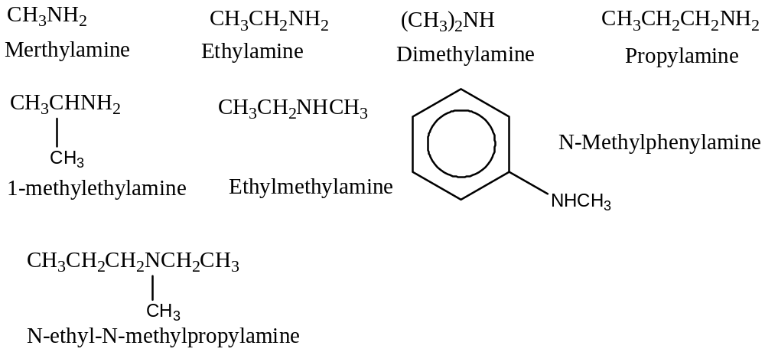
More complex tertiary amines with different alkyl groups are named as derivatives of the longest chain and “N” is inserted before the named of each group.
For aromatic amines, the names are derived from the simplest aromatic amine i.e. Phenylamine.
Methylphenylamines are collectively termed as Toluidines.
Synthetic Preparation
- From Alkyl halides
This method generates a mixture of amines. Therefore their separation fractional distillation is used.
However better yield are obtained when Primary amine reacts with haloalkane compounds to generate secondary or tertiary amine.
The method also is suitable for preparation of Aromatic amine since aromatic halides do not react with ammonia under normal condition.
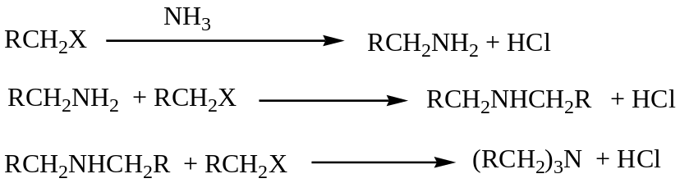
- Reduction of Nitro compounds
Nitro compounds are reduced to Primary amines using Lithium Aluminium hydride or hydrogen gas in presence of a catalyst.
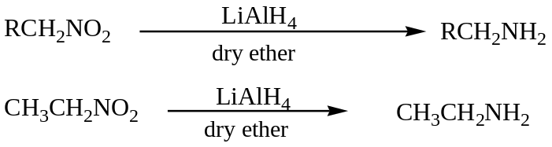
For aromatic amines, tin and concentrated hydrochloric acid is used for reduction of aromatic nitro compounds.
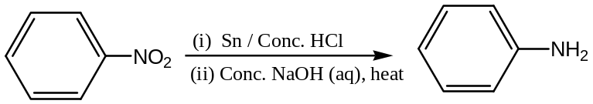
- Reduction of Nitriles
Nitriles are reduced to primary amines by lithium aluminium hydride or hydrogen in presence of a catalyst.
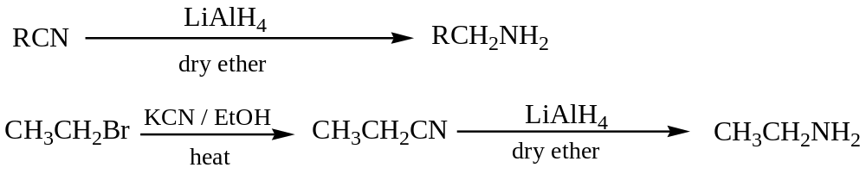
A further application is reduction of Oximes.
- Hofmann degradation of Amides.
This reaction gives a good yield of primary amine of a lower carbon chain.
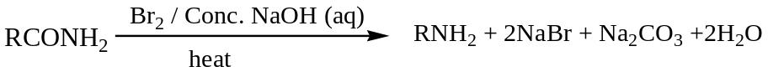
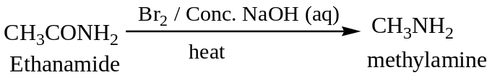
- Reduction of amides
Primary or Secondary or tertiary amides are reduced to their respective amines using lithium aluminium hydride in dry ether.
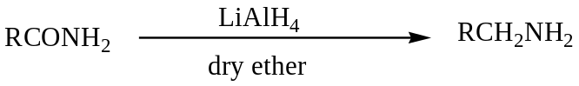
Properties of Amines
Simple aliphatic amines are gases and possess a characteristic smell of ammonia. However most of the higher homologues are liquids with rotten fish smell.
They are polar compounds and the molecules form intermolecular hydrogen bonds with each other except tertiary amines.
For isomeric amines, the boiling points decrease in the order of 1o>2o>3o due to progressive decrease in intermolecular hydrogen bond.
The hydrogen bonds in alcohols are stronger than those in amines because oxygen is more electronegative than nitrogen atom therefore the boiling points of alcohols are higher those of amines of relatively the same molecular mass.
Lower molecular mass amines are soluble in water because the molecules form hydrogen bond with water molecules and the resultant solution is basic .i.e. turns red litmus blue.
Basic Strength of Amines
The basic strength of amines depends on availability of lone pair of electrons on the nitrogen atom for protonation. Primary amines are more basic than ammonia due to presence of alkyl group which is electron releasing group therefore great salvation.
Secondary amines are more basic than Primary amines since they have two electron releasing groups hence more solvation.
Tertiary amines are less basic than both Primary and Secondary amines but more basic ammonia since they have three alkyl groups which are electron releasing groups’ hence greater positive inductive effect or more electron releasing hence less solvation due to steric hinderance.
Aromatic amines are weaker or less basic than aliphatic amines because of the presence of benzene ring where the lone pair of electrons on the nitrogen atom gets delocalized.Thus lone pair of electrons on the nitrogen atom becomes less available for protonation.
The Table gives the base dissociation and their boiling points of amines.
Amines | M.p.t (ºC) | B.p.t(ºC) | K_{b}
CH₃CH₂NH₂ | -84 | 17 | 5.6X10⁻⁴
CH₃CH₂NHCH₂CH₃ | -48 | 56 | 9.6X10⁻⁴
(CH₃CH₂)₃N | -115 | 90 | 5.7X10⁻⁴
C₆H₅N(CH₃)₂ | 3 | 194 | 11.5X10⁻⁵

Reaction of Amines
Majority of the reactions of amines indicate aminesaselectron rich species (Nucleophiles). Therefore some of the reactions of amines include:
- Salt formation
As bases, amines react with acids to form salts.
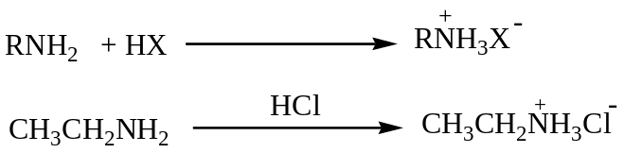
Generally the salts are soluble in water but insoluble in organic solvents. Therefore amines are soluble in dilute mineral acids.
- Amide formation
Both aliphatic and aromatic primary or secondary amines readily acylated using acyl halides or acid anhydrides
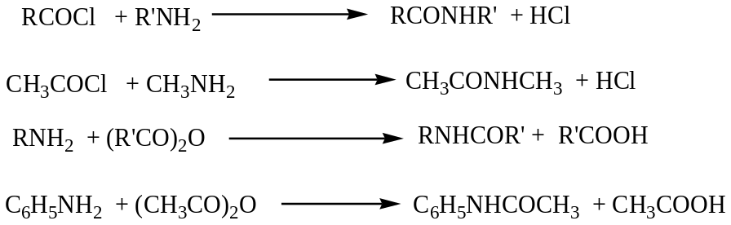
Qn: Write the mechanism of the above reaction
- Alkylation of amines
Primary and secondary halides react with amines to form alkylated amine.
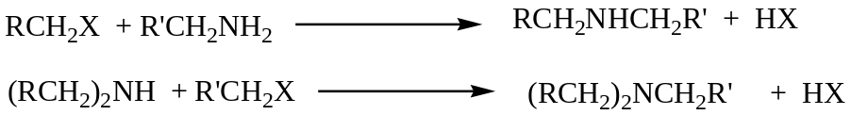
Qn: Write the mechanism of the above general reactions.
- With Nitrous acid
Nitrous acid is unstable at room temperature therefore usually prepared in the reaction mixture using sodium nitrite and concentrated hydrochloric acid at low temperatures usually below 10ºC.
The reaction mixture is used to differentiate between the classes of amines.
- With Primary Aliphatic amines
They react to unstable alkyl Diazonium salt that decomposes to a colourless solution and bubbles of colourless gas.
- With Secondary amines
Both aliphatic and aromatic secondary amines react forming yellow oily liquids.
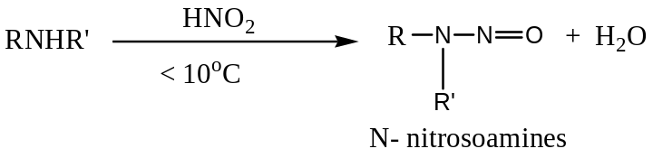
- With Tertiary amines
They with nitrous acid forming a colourless solution without evolution of bubbles of a colourless gas
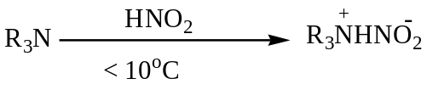
- With Primary Aromatic amines
They react forming benzene Diazonium salt which is a stable colourless solution below 10ºC.
The reaction between primary aromatic amine with nitrous below 10ºC is known as diazotization.
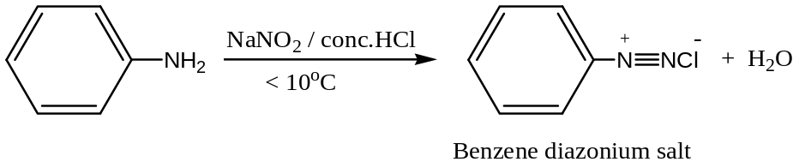
Above 10ºC, there is effervescence of a colourless gas and colourless liquid of phenol.
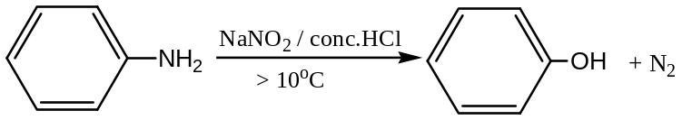
Reactions of Benzene Diazonium salt
Benzene Diazonium salt are prepared by action of nitrous acid on Phenylamine below 10oC.
They undergo two types of reactions i.e.
- Nucleophilic substitution reaction
- With water.
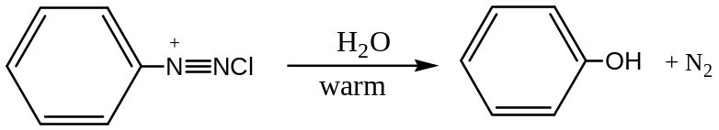
- Halogen substitution
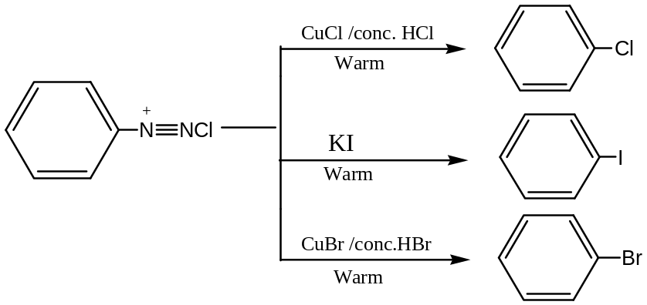
- Cyanide substitution
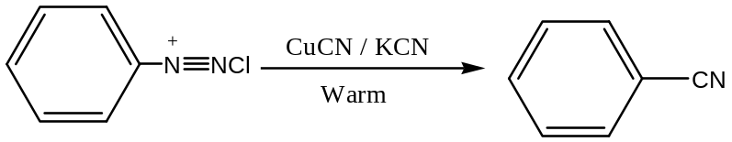
- Coupling reactions
These reactions are usually used to generate azo dyes.
- With Phenol
In alkaline medium benzene Diazonium salt react with phenol form a yellow azo dye.
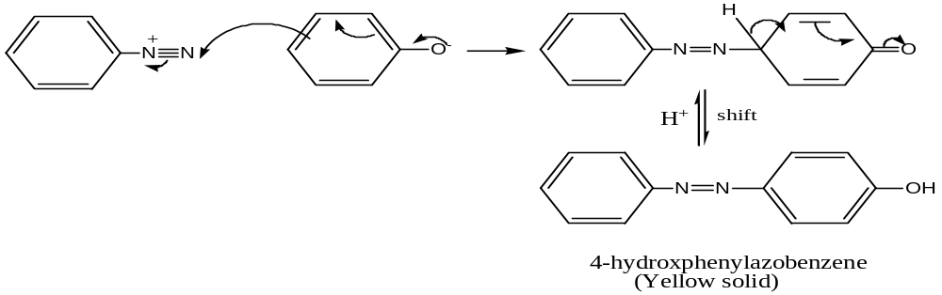
- With Napth-2-ol
Benzene Diazonium salt forms a red azo dye in presence of alkaline medium also.
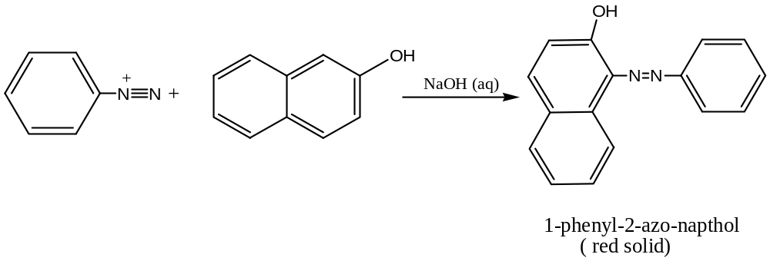
- With amines
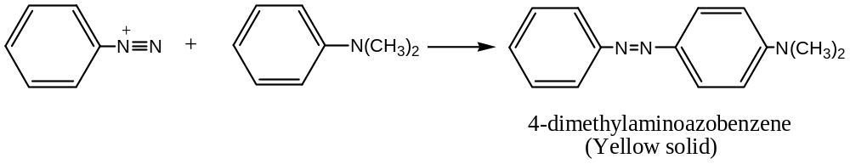
Qn: Write the mechanism of this reaction
Reaction of Aromatic amines (Substitution in the Benzene ring)
The amino group directs the incoming group to position 2 and 4 and activates the benzene ring towards Electrophilic substitution reactions.
Phenylamine reacts with Bromine forming a white precipitate of 2,4,6-tribromophenylamine.
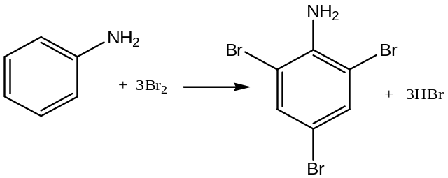

CHAPTER ELEVEN

SOAP AND DETERGENTS
SOAP
Sodium salt of long carboxylic acid is known as soap. Soap is usually obtained from Fats or Oils.
Fats and Oils are complex mixtures of glycerol with a long chain carboxylic acid. Fats are solids at room temperature while Oils are liquids.
Fats tend to contain greater proportion of unsaturated acids while Oils tend to contain greater proportion of saturated acids.
The sources of oils are cotton seed, simsim, groundnut, sunflower seed, soya beans and coconut etc while fats are obtained from animals such as Pigs, Sheep or Cows.
Preparation of Soap
Soap is prepared by a reaction known as saponification.
Roast the dry seeds; crush/grind to make paste. Boil with water until oil floats on top and decant off the oil. Mix the oil with excess sodium hydroxide solution and boil while constant stirring for a long time.
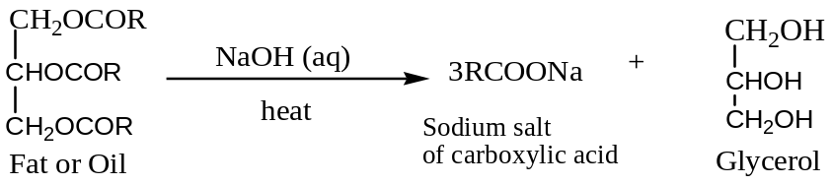
Add concentrated sodium chloride solution (Brine) to precipitate out the soap.
Cleansing Action of Soap
Soap lowers the surface tension between water and oil or insoluble material. They do so because they contain a polar group (-COO⁻) and a non-polar alkyl chain (R-). The molecule of water congregates near the polar end while the molecules of oil congregate around the alkyl group. The non-polar oil particles are emulsified into suspension and removed.
N.B. Hard water affects the cleansing action of soap. Hard water contains calcium or magnesium ions. These ions react with soap to form a precipitate known as Scum.
Lather cannot be formed until when the entire calcium or magnesium ions are completely removed as scum. This wastes soap in hard water.

DETERGENTS
These are substances which improve the cleansing properties of water since they are sodium salts of long chain alkyl sulphonate or alkyl sulphate
Features of Detergents
Detergents have along chain hydrocarbon end which is oil or Fat soluble and hydrophilic part which is the sulphonate group. Thus detergents are sodium salts of sulphonic acids.
Since Detergents are alkyl benzene sulphonate examples include:
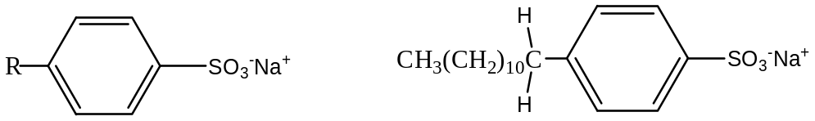
Common detergents include Nomi, Omo, surf, teepol etc.
Properties of detergents
- They are highly soluble in water
- Detergents are emulsifying agents.
Preparation of Alkyl Benzene sulphonate
Soap less detergent is prepared as follows:
Benzene is alkylated in presence of a halogen carrier. The alkylated benzene is then sulphonated with concentrated sulphuric acid and the sulphonic acid formed is reacted with sodium hydroxide solution to form the detergent. i.e.
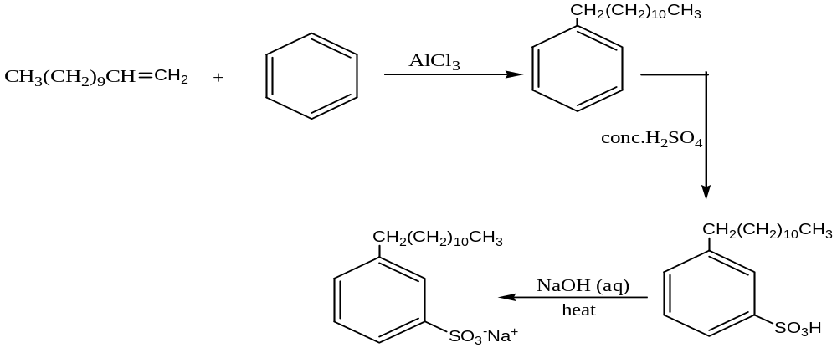
The table below shows the types of detergents and their uses.
Types | Nature | use
Anionic detergent | These have negative heads  e.g CH₃(CH₂)₁₁CH₂OSO₃⁻Na⁺ | Used for manufacture of toothpaste and shampoo
Cationic detergent | These have positive heads  e.g C₁₅H₃₁N(CH₃)₃Br | Used for hair conditioners
Non-ionic detergents | These are neutral in water  i.e. these carry no charge | Used for making liquid detergents

Action of Detergents on Fabrics
The action of detergents on fabrics is the same as that of soap.
Detergent Additives
- Sodium Sulphate: This is used to increase the bulk of the detergent.
- Detergent builders (Inorganic phosphate): These are used as water softeners because they form soluble complexes with calcium or magnesium ions in hard water.
- Peroxyborates: These are used as bleaching agents.
Advantages of Soap over detergents
- Soap is biologically degradable
- Soap can be used for both bathing and washing
Disadvantage of Soap over detergents
They form undesirable scum with hard water which leads to wastage of soap
Advantages of detergents over soap
- They are used in any of water.
- Detergents have a brighter cleansing effect
Disadvantages of detergents over soap
- Detergents are non biodegradable
- Detergents contain fertilizer materials such as phosphates which nourish the growth of algae hence reducing oxygen supply in water.
Question:
a) Some oils are used in the manufacture of soap.
- Name the reaction leading to the formation of soap
- Outline how soap is manufactured from oil.
- Write an equation of reaction between hard water and soap
- Explain briefly why soap is not commonly used in washing aluminium utensils
- A sample of soap was prepared from 9.5g of oil containing an ester of hexadecanoic acid (C₁₅H₃₁COOH). Calculate the mass of soap formed.
b) Synthetic detergents are gradually replacing soap as cleansing agents.
- Write equations to show how a soap less detergent can be prepared from 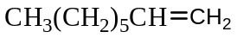
- What problem does detergent cause to the environment
- State one structural difference between soap and detergent
- Describe the cleansing action of Omo as a detergent
- 0.6cm³ of Jik was dissolved in water and solution made in 250cm³ volumetric flask. 25cm³ of this solution was acidified and 10cm³ of 0.2M potassium iodide solution added. The iodine liberated required 5.0cm³ of 0.2M Sodium thiosulphate solution for complete reaction. Calculate the mass of Chlorine in 1dm³ of Jik.

POLYMERISATION
This is the building of large molecules (polymer) by linking together very many small molecules (monomers) with or without loss of small molecules such as water, ammonia etc.
Polymers are long chain molecules with recurring structural units formed by polymerization process.
When the recurring units are different, a co-polymer is formed.
Factors that determine the properties of Polymers
- Chain length: Strength and melting points of polymers increase with increase chain length
- Branching: Increased branching reduces the molecular strength and lowers the melting point
- Cross linkage: Polymers with a cross link between the chains form a rigid network which increases the strength.
- Intermolecular forces: Stronger intermolecular forces between the chains result into higher melting points.
Types of Polymers
1. Natural Polymers
These are polymers whose formation is not controlled by man. These include Cellulose material (Cotton, paper), Protein material (wool, silk), Natural rubber and Rayon.
2. Synthetic Polymers
These are polymers that are man made. These include Plastics and fibers, addition polymers (polyethene, polypropene, and polyvinylchloride), Condensation polymers (Polyesters, nylon 6, 6)
Natural Rubber
Rubber is obtained naturally from rubber trees as milky liquid called latex.
Natural rubber is a polymer derived from 2-methylbut-1, 3-diene I,e
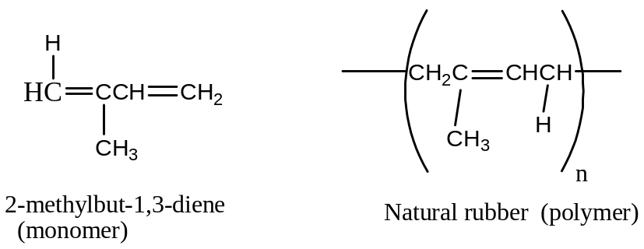
Natural rubber is very soft and of little use. It is made hard and tough by heating it with sulphur by a process known as Vulcanisation.
Vulcanisation
This is the process of improving on the qualities of rubber by heating it with sulphur.
The sulphur atoms add to some double bonds of two neighbouring rubber molecules to form vulcanized rubber.
The hardness of vulcanized rubber is directly proportional to the amount of sulphur added.
The following are the effects of heating natural rubber with sulphur:
- It improves on temperature working range
- It improves on toughness
- It improves on elasticity
- It improves on Bulkiness
Vulcanized rubber therefore is used for making car tyres, shoe sole, gloves and insulating electric cables.
Synthetic Polymer
Addition Polymers
Addition Polymerization
This is the building up of a large molecule from a number of unsaturated monomers to form a single product.
Addition polymers include:
Polyethene: These exsit in two forms i.e. High density and lower density polymer.
Low density polymer: This is formed in presence of a catalyst i.e.
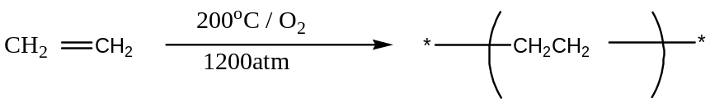
Low density polyethene is used for making plastic bags, packing materials, electric cables, insulators.
High density polyethene: This is formed when ethene undergoes polymerization at 60ºC and 1 atmosphere. i.e.
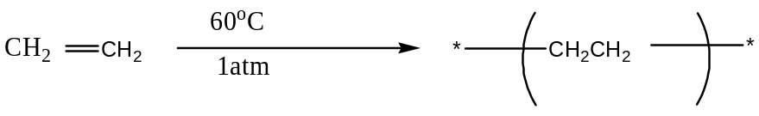
High density polyethene is used for manufacture of water tanks, plastic pipes, plastic bottles, crates, buckets and kitchen ware.
Polyethenedon’trot, insoluble in most common solvents and less dense than water.
Polyvinylchloride (PVC)
The monomer is chloroethene. Chloroethene undergoes polymerization at high pressure and temperature in presence of peroxide i.e.
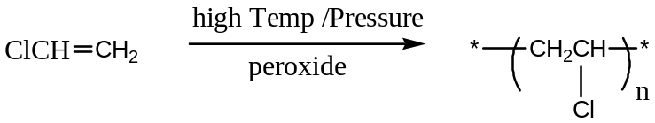
The properties of PVC are water proof, non-degradable, not attacked and easily destroyed on heating.
PVC is used for making plastic coats, umbrellas, electronic equipments, suitcases and insulating electric cables.
Polypropene
This is formed from propene at 100ºC and 100atmosphere in presence of peroxide.
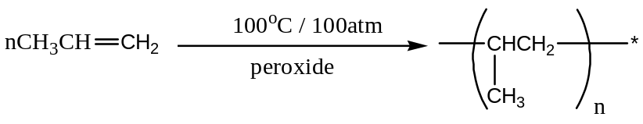
Polypropene is used for making beer bottle crates, drinking straws, ropes and surfaces of all weather football and hockey pitches.
Polystyrene / Polyphenylethene
The monomer is phenylethene. Polystyrene is used for making combs, packing materials, ceilings and toys.
Perspex
This is an addition polymer whose monomer is 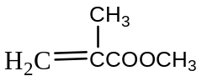.
Perspex is used for making lenses, laboratory glass ware, windows of cars and airplanes, corrugated roof lights and in packaging.
Condensation Polymers
Condensation polymerization occurs when molecules that are bifunctional or polyfunctional react together to form a polymer and another product with small molecules.
Nylon 6,6
The monomers are diaminohexane and hexanedioic acid. It is called Nylon 6, 6 because each of the monomers has got six carbon atoms.
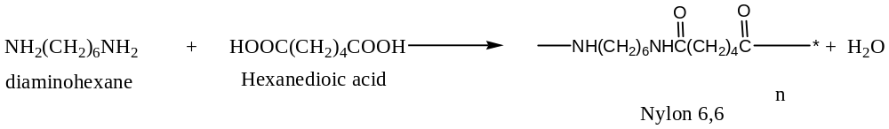
Nylon 6,6 has the following properties:
- It is water repellent hence dries easily
- It has got a hard warring tendency
- Insoluble in most solvents
- Fuses at temperatures above 200ºC
Nylon 6,6 is used for making of stockings, gloves, clothes, carpets and fishing nets.
N.B. Nylon 6,10 has monomers 1,6-diaminohexane and decanedicyldichloride and it is used for making surgical gloves, curtains , fishing nets and carpets.
Nylon polymers are also known as polyamides since they contain the peptide bond with in the molecule.

Polyester / Terylene
Made by condensing Ethane-1,2-diol and Benzene-1,4-dicarboxylic acid with loss of water molecules. i.e.
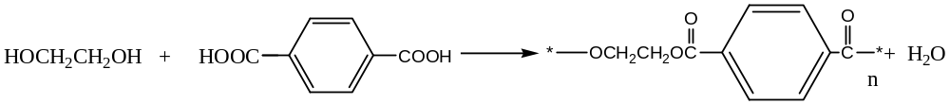
It is used for making clothes (textiles), ropes, safety belts and tents.
Differences between Addition polymerization and Condensation polymerization
 | Addition polymerization | Condensation polymerization
1 | Addition polymers are linear | Condensation polymers are non-linear
2 | The monomers used are similar | Monomers used are different
3 | Addition polymerization can be reversed | Condensation polymerization is irreversible

Advantages of Synthetic polymers over natural polymers
- Easier to manufacture
- Relatively stronger than the corresponding natural polymer
Disadvantages of Synthetic polymers over Natural polymers
- Non-biodegradable
- Its manufacture involves release of toxic fumes which cause a health hazards to Human.
Plastics
A plastic is a substance which when heated becomes soft and can be moulded into different shapes.
Properties of Plastics
- Become soft on heating
- Non-biodegradable
- Not attacked by acids or alkali
The properties of plastics can be modified by addition of:
- Plasticizers: these are substances which soften and make plastics easily moulded.
- Dyes and pigments: used to colour plastics
- Fillers: are used to increase the bulk of Plastics.
Types of plastics
- Thermosofthening plastics (Thermoplastics)
These are plastics which when heated soften and can be remoulded into different shapes. This is because the binding forces between the polymer chains are weak and also have fewer cross-linkages between the polymer chains (or linear pattern arrangement).
Thermoplastics include Polypropene, polyethene, polystyrene, polyvinylchloride etc.
- Thermosetting plastics (Thermosets)
These are plastics which when heated donot soften but harden and can not be remoulded in to different shapes. This is because they are held together by much cross-linkage between the polymer chains.
Thermosets include Bakelite used for making electric plugs, sockets and switches.
Advantages of Plastics over metals
- Plastics are resistant to attacks by acids, alkalis and atmospheric oxygen (corrosion).
- Easier to be recycled.
- Lighter than metals
Disadvantages of Plastics over metals
- Plastics items easily burn
- Pollutants since they are non-biodegradable
- You are provided with organic substance Z whose nature is required to be determined. Record your observation(s) and deduction(s) in the table below

Sample OrganicPractical’s
Sample one
You are provided with organic substance Z whose nature is required to be determined. Record your observation(s) and deduction(s) in the table below
TEST | OBSERVATION(S) | DEDUCTION(S)
(a) Burn a small amount of Z on crucible lid. | Burns with non-sooty flame | Aliphatic compound present
b) To 1cm³ of Z, add 2cm³ of water and shake the mixture. Test with litmus. | Soluble in water. Solution is neutral to litmus | Alcohols, carbonyl compounds present
c) To 1cm³ of Z, add five drops of Brady’s reagent. | No observable change  Or  No yellow precipitate formed | Carbonyl compound absent
(d) To 2cm³ of Z, add acidified Potassium dichromate and warm. | Orange solution turns green | Primary, secondary alcohol probably present
(e) To 2cm³ of Z, add Lucas reagent. | Cloudiness formed after a short time. | Secondary alcohol present
(e) To 2cm³ of Z, add conc. Sulphuric acid, heat and pass the vapour through acidified Potassium permanganate solution. | Colourless gas turns acidified  Purple solution turns colourless | Dehydration of alcohol leading to formation of an alkene.
(f) To 1cm³ of Z, add Iodine solution followed by sodium hydroxide solution drop wise until the Iodine is discharge and warm. | Yellow precipitate | Secondary alcohol contains a methyl radical adjacent to the carbon atom carrying the functional group

Comment on the nature of Z
Z is an aliphatic secondary alcohol with structure
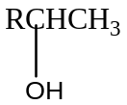
Sample Practical Two
You are provided with organic substance K. You are required to identify the nature of K. Carry out the following tests on K and record your observations and deductions in the table below.
TEST | OBSERVATION(S) | DEDUCTION(S)
(a) Burn a spatula end -ful of K on a porcelain dish. | Burns with non-sooty flame | Aliphatic compound present
(b) Shake 3cm³ of K with 2cm³ of water and allow to it stand. Test with litmus. | Soluble in water. Solution is neutral to litmus | Alcohol , Carbonyl compounds probably present
(c )To 2cm³ of K in test tube, add Brady’s reagent. | Yellow precipitate formed | Carbonyl compound present
(d)To 2cm³ of K, add saturated sodium hydrogen sulphite solution. | White precipitate formed | Carbonyl compound present
(e) To 1cm³ of K in the test tube, add acidified potassium dichromate and warm. | No observable change | Aldehydes absent  Or  Ketones present
(f) To 3cm³ of silver nitrate solution, add 2cm³ of sodium hydroxide then ammonia drop wise until the precipitate dissolves followed by 3cm³ of K. Then warm. | No silver mirror formed  Or  No observable change | Aldehydes absent  Or  Ketones present
(g) To 2cm³ of K, add iodine followed by sodium hydroxide until the colour is discharged. Warm the mixture and cool under water. | Yellow precipitate formed | Methyl radical attached to the carbon atom carrying the functional group.

(h) Comment on the nature of K
K is aliphatic carbonyl compound with a structure of
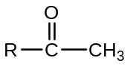

Sample Practical Three
You are provided with an organic substance J whose nature is required to be determined. Carry out the following test on J.
TEST | OBSERVATION(S) | DEDUCTION(S)
a) Burn a small amount of J in a spatula. | Burns with yellow sooty flame | Aromatic compound present
b) To a half spatula end ful of J, add 1cm³ of water and with test with methyl orange indicator. | Slightly soluble in water. Solution turns methyl orange pink / red | Phenol or Carboxylic acid present
c) To a half spatula end ful of J, add 2-3 drops of iron (III) chloride solution. | No violet colouration formed | Phenol absent
d) Boil a spatula end ful of J with sodium hydroxide solution for three minutes. | Dissolves to form a colourless solution | Acidic compound present  Therefore carboxylic acid present.
e) Add sodium carbonate solution to about a spatula end ful of J. | Slight effervescence  Or  Bubbles of colourless gas | Carboxylic acid present
f) Add a spatula endful of J in about 2cm³ of water followed by acidified potassium manganate(VII) solution | Purple solution turns colourless | Compound is Unsaturated
f) Add 1cm³ of ethanol to a spatula end ful of J followed by concentrated sulphuric acid. Boil the mixture and pour into a beaker of water. | Sweet fruity smell formed | Esterification occurred  Therefore Carboxylic acid present.
g) Add 3cm³ of water to a spatula end-ful of J in a test tube. Then add soda lime and Heat strongly. | Colourless gas formed | Decarboxylation occurred  Therefore Carboxylic acid present.

(h) Comment on the nature of J
J is an aromatic unsaturated compound with a carboxyl group attached.
Sample Practical Four
You are provided with an organic compound Q. You are required to determine the nature of Q. Carry out the following tests on Q and record your observations and deductions in the table below.
Tests | Observations | Deductions
a) Burn a small amount of Q on crucible lid | Burns with a yellow sooty flame | Aromatic compound present
b)Add a spatula end-ful of Q to about 3cm³ of dilute sodium hydroxide solution and shake | Soluble to form a colourless solution | Acidic compound present.  Therefore Phenol ,carboxylic acid probably present
c) To a spatula end ful of Q in a test tube add 4cm³ of water. Shake vigorously and warm. Test the solution with litmus paper and divide the resultant solution into three portion | Slightly soluble in cold water and soluble on warming. Turns blue litmus red | Phenol, Carboxylic acid probably present
(i) To the first portion, add three drops of 2,3-dinitrophenylhydrazine | No observable change  Or  No yellow precipitate formed | Carbonyl compound absent
(ii) To the second portion, add 3 drops of iron (III) chloride solution | Violet colouration formed | Phenol absent
(iii) To the third portion, add endful of solid sodium hydrogen carbonate | Effervescence occurred  Or  Bubbles of colourless gas | Carboxylic acid present
d) To 3cm³ of methanol, add a spatula end-ful of Q and shake. Add 3-4 drops of concentrated sulphuric acid and warm the mixture | Sweet fruity smell | Esterification occurred  Therefore carboxylic acid confirmed.

(e) Comment on the nature of Q
Aromatic compound with a hydroxyl and carboxyl groups attached to benzene ring.
Sample Practical Five
You are provided with organic substance J whose nature is required to be determined.
Carry out the following tests on J and identify the functional groups in J.
TEST | OBSERVATION(S) | DEDUCTION(S)
a) Burn a small amount of J in a crucible lid. | Burns with yellow sooty flame | Aromatic compound present
b) To 2cm³ of J, add 2cm³ of water and warm the mixture and test with litmus paper. Divide the warm solution into four parts. | Slightly soluble in water. Solution is neutral to litmus. | Alcohol or Carbonyl compound probably present
(i) To the first part, add 2-3 drops of sodium carbonate solution. | No observable change | Carboxylic acid absent
(ii) To the second part, add 2-3 drops of iron (III) chloride solution. | No observable change  Or  No violet colouration formed | Phenol absent
(iii)To the third part add 2,4-dinitrophenylhydrazine solid followed by 2cm³ of ofconcentrated sulphuric acid. | Yellow precipitate formed | Carbonyl compound present
(iv) To the fourth part, add 2-3drops of acidified potassium dichromate solution and warm. | Orange solution turns green | Aldehydes present  Or  Ketones absent
c) To 2cm³of J, add silver nitrate solution followed by sodium hydroxide solution then ammonia solution until the solid dissolves. Warm the mixture. | Silver mirror formed | Aldehydes present
d) To 3cm³ of J, add iodine solution followed by sodium hydroxide solution and warm the mixture | No observable change  Or  No yellow precipitate formed | Methyl Aldehyde absent
e) To 3cm³ of J, add Fehling solution and heat the mixture | Brown precipitate formed | Aldehyde present
f) To 3cm³ of J, add acidified potassium manganate (VII) solution. | Purple solution turns colourless | Compound is unsaturated

e) Comment on the nature of J
J is an unsaturated aromatic compound with a carbonyl group attached.

Sample Practical Six
You are provided with an organic substance Q. Carry out the following tests on Q to identify its nature.
Record your observations and deductions in the table below.
Tests | Observations | Deductions
(a) Burn a small amount of Q on a spatula end | Burns with a yellow sooty flame | Aromatic compound present
(b) Shake 3 drops of Q with about 3cm³ of water and test with litmus | Slightly soluble in water.  Solution turns red litmus to blue | Basic Compound present  Therefore Amines present
(c) Place 2cm³ of dilute hydrochloric acid in a test tube followed by 3 drops of Q | White fumes are formed.  Soluble in acid | Amines present
(d) To 3drops of Q add concentrate hydrochloric acid until the mixture is just acidic the add 1cm³ of sodium nitrite solution followed by 2-napthol in sodium hydroxide solution | Red precipitate formed | Azo dye formed  Primary aromatic amine present
(e) To 3drops of Q in a test tube add concentrate hydrochloric acid until it dissolves. Then add bromine water drop by drop until in excess. | White precipitate | Primary Aromatic amine
(f) To three drops of Q in a test tube,add acidified potassium manganate(VII) solution. | Purple solution turns colourless | Unsaturated compound present.

Comment on the nature of Q
Q is unsaturated primary aromatic amine.

